Received 27 September 2024; revised 10 November 2024; accepted 30 November 2024. Date of publication 9 December 2024; date of current version 8 January 2025.
Digital Object Identifier 10.1109/OJCOMS.2024.3513832
Federated Learning for 6G Networks: Navigating
Privacy Benefits and Challenges

CHAMARA SANDEEPA¹ (Student Member, IEEE), ENGIN ZEYDAN² (Senior Member, IEEE),
THARAKA SAMARASINGHE(Senior Member, IEEE), AND MADHUSANKA LIYANAGE ¹ (Senior Member, IEEE)
3
¹School of Computer Science, University College Dublin, Dublin 4, D04 V1W8 Ireland
²Services as Networks (SaS) Research Unit, Centre Tecnològic de Telecomunicacions de Catalunya, 08860 Barcelona, Spain
³Department of Electronic and Telecommunication Engineering, University of Moratuwa, Moratuwa 10400, Sri Lanka
CORRESPONDING AUTHOR: M. LIYANAGE (e-mail: madhusanka@ucd.ie)
This work was supported in part by the European Union through the Project Confidential-6G under Grant 101096435, through the Project Robust-6G under Grant 101139068, and the Science Foundation Ireland under the CONNECT Phase 2 under Grant 13/RC/2077_P2; in part by the Spanish Ministry of Economy and
Competitiveness (MINECO)—Program UNICO I+D under Grant TSI-063000-2021-54 and Grant TSI-063000-2021-55; in part by the “ERDF A Way of Making
Europe” Project funded by MCIN/AEI/10.13039/501100011033 under Grant PID2021-126431OB-I00; and in part by the Generalitat de Catalunya under Grant 2021 SGR 00770.

ABSTRACT The upcoming Sixth Generation (6G) networks aim for fully automated, intelligent network functionalities and services. Therefore, Machine Learning (ML) is essential for these networks. Given stringent privacy regulations, future network architectures should use privacy-preserved ML for their applications and services. Federated Learning (FL) is expected to play an important role as a popular approach for distributed ML, as it protects privacy by design. However, many practical challenges exist before FL can be fully utilized as a key technology for these future networks. We consider the vision of a 6G layered architecture to evaluate the applicability of FL-based distributed intelligence. In this paper, we highlight the benefits of using FL for 6G and the main challenges and issues involved. We also discuss the existing solutions and the possible future directions that should be taken toward more robust and trustworthy FL for future networks.
INDEX TERMS Privacy, federated learning, 6G, beyond 5G, AI, distributed learning, machine learning.

I. INTRODUCTION Several use cases exist in B5G/6G networks, such as
T
HE INTRODUCTION of Beyond 5G (B5G) and 6G smart cities, smart factories, smart energy grids, smart networks opens a new era of connectivity charac- healthcare, and smart consumer applications [4]. In smart

terized by immersive communication, integrated Artificial Intelligence (AI), massive, hyper-reliable and low-latency communication, ubiquitous connectivity, and integrated sensing. These advances promise to revolutionize various sectors, including healthcare, industrial automation, smart cities, and autonomous vehicles, by enabling sophisticated AIdriven applications [1]. However, the increasing reliance on AI and the extensive data collection required for these applications create significant privacy issues [2]. Traditional centralized machine learning approaches, which require aggregating data from multiple sources on a central server, pose a significant risk of data breaches and unauthorized access [3].
c 2024 The Authors. This work is licensed under a Creative Commons Attribution 4.0 License.
For more information, see https://creativecommons.org/licenses/by/4.0/
90 VOLUME 6, 2025
cities, sensors and connected devices manage urban infrastructure, transportation, and public services. Smart factories use industrial Internet of Things (IoT) devices and sensors to improve manufacturing processes, monitor machines, and ensure efficient production. Smart energy grids, smart meters, and grid management systems are used to optimize energy distribution and consumption. In smart healthcare, wearable devices and health monitoring systems track patient health data and provide personalized care. In smart consumer applications, various applications for personal use, such as smart home appliances, wearables, and personal assistants, are used. These use cases can also face specific privacy threats, as shown in Figure 1.
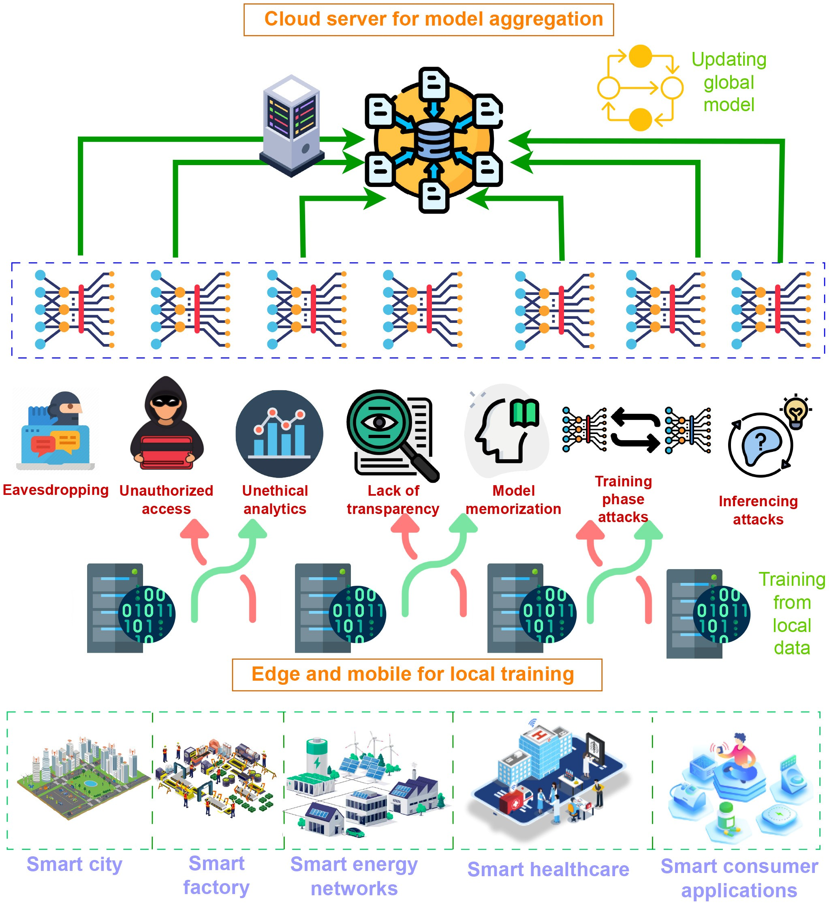
FIGURE 1. Overview of privacy challenges on B5G/6G.
FL effectively solves these privacy challenges as it enables decentralized model training [5]. With FL, the individual devices train a shared model together, keeping their data local and thus minimizing the need to transfer sensitive information. This approach fits well with the privacy requirements of 6G networks, where the sheer volume and data sensitivity require robust privacy mechanisms [6]. By leveraging FL, data remains on local devices, significantly reducing the risk of data breaches compared to traditional centralized methods. This is particularly relevant in 6G networks, which are expected to support many connected devices and handle unprecedented amounts of data [7]. Therefore, the combination of FL and 6G technologies can help maintain data privacy while enabling the deployment of advanced AI applications.
In a typical FL workflow, local devices (e.g., smartphones, IoT devices) train with local data and ensure that the raw data does not leave the device. Model updates are sent from local devices to a central cloud server and aggregated into a global model. Some privacy challenges in FL are: eavesdropping, which is unauthorized interception of data transmitted between local devices and the cloud server, which can lead to data leaks [8], unauthorized access, the illicit access to sensitive data or model updates by unauthorized persons or entities [9], unethical analytics, which is a misuse of data or model outputs for purposes not intended or ethical, such as profiling or targeted advertising without consent [10], lack of transparency, i.e., insufficient clarity about how data is used, processed, and shared, leading to a lack of trust among users [11], model memorization, i.e., the risk that the global model stores sensitive information from the training data that could be extracted later [12], training phase attacks, i.e., attacks that take place during the local training phase, such as poisoning the data to bias the model [13], and inference phase attacks, where attempts are made to derive sensitive information from the results of the model, which could jeopardize the privacy of individuals [14].
To overcome these challenges, advanced privacypreserving techniques must be integrated into FL. Techniques such as Differential Privacy (DP) can add noise to data to obscure individual contributions [15], while Homomorphic Encryption (HE) enables computations on encrypted data without decrypting it [16]. Secure Multiparty Computation (SMC) enables joint computations while keeping the inputs private [17]. In addition, auditability and transparency mechanisms can provide users with clarity on how their data is used, processed, and shared, increasing trust in FL systems [18]. Maintaining privacy at the different layers of 6G networks is also important to ensure comprehensive security and data protection. Robust security measures must be implemented at the device level to prevent unauthorized access and data leakage from user devices. Over The Air (OTA) communication must be secured to protect data integrity during transmission. At the edge AI level, privacy mechanisms should ensure that sensitive information is not exposed during data processing and model training at the network edge. In addition, intelligent network management and orchestration must include FL to protect privacy across the network dynamically. Each layer requires specific strategies and technologies to address the unique privacy challenges and ensure a multi-layered and resilient approach to privacy in 6G networks.

A. MOTIVATION AND CONTRIBUTIONS
The motivation for this paper stems from the increasing demand for privacy in the era of ubiquitous connectivity and AI-driven decision-making, which will be expanded in 6G networks. Despite the numerous surveys on FL-enabled security and privacy for 6G, our survey fills important gaps left by previous works. While many existing surveys focus broadly on FL or specific areas such as IoT or healthcare, this survey provides a focused and comprehensive examination of the unique security and privacy challenges in the context of 6G networks. Having identified the related challenges, we propose ways to integrate additional privacy-enhancing techniques to strengthen the privacypreserving capabilities of FL in protecting user data while maintaining the performance and scalability required for 6G applications. Our survey also offers an in-depth analysis of how FL can be effectively applied to different layers of 6G networks, including devices, communication channels, edge AI, and network management–an area often overlooked by other surveys. In addition, we adopt a multi-layer privacy preservation approach, diving into strategies for ensuring privacy at different levels of the 6G architecture. This is a crucial advancement, as many existing works do not explore
TABLE 1. Summary of important acronyms.
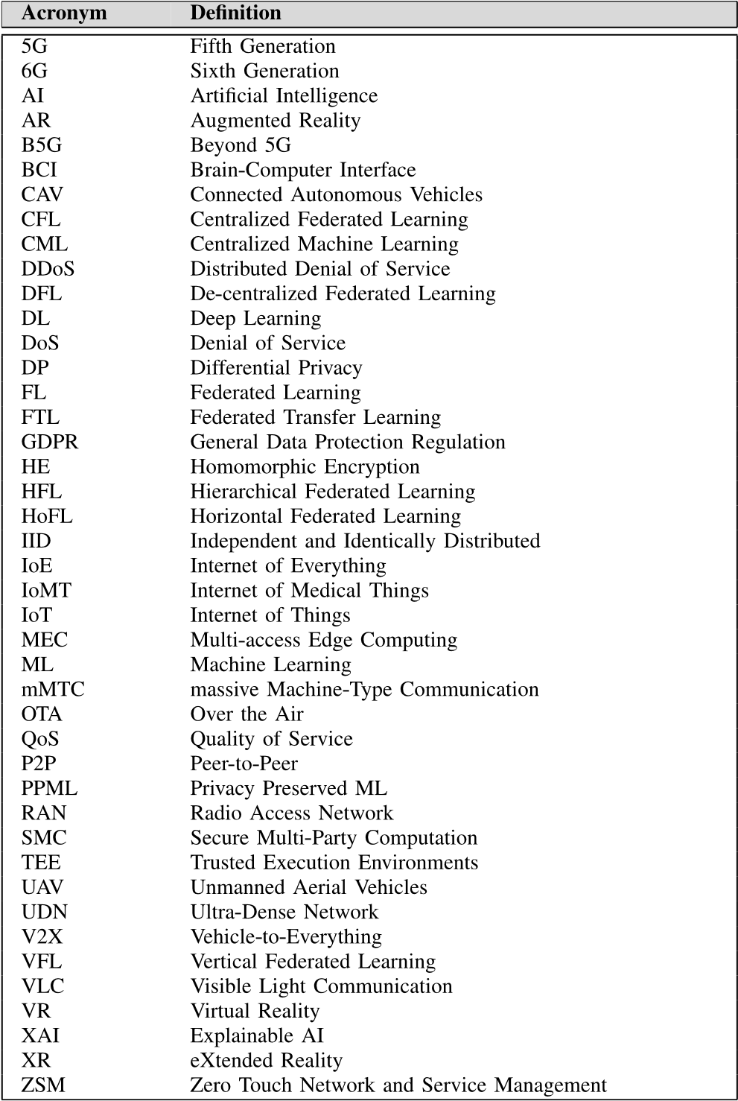
privacy solutions in such a detailed and layered manner. Finally, we offer an in-depth look at lessons learned and future research directions, particularly concerning privacypreserving mechanisms in 6G and the wider integration of FL. Our contributions can be summarized threefold: • We provide a comprehensive overview of FL and its role in 6G networks, detailing how FL can leverage the unique features of 6G to enhance privacy and security.
- We discuss use cases and architectural components that highlight the benefits of FL for privacy in 6G. We show how FL ensures data confidentiality and integrity through decentralized data processing and enables secure model training and aggregation in different use cases. We also discuss the implementation frameworks and tools of FL for 6G implementations.
- We address key privacy challenges associated with FL in the context of 6G networks and propose potential solutions to enhance FL’s effectiveness in protecting user data. These challenges include model memorization, training phase attacks, inference attacks, eavesdropping, unauthorized access, and unethical analytics. We propose integrating privacy-enhancing techniques such as DP, SMC, HE, and secure aggregation protocols to mitigate these risks. Furthermore, we provide trade-offs of these solutions on 6G and approaches to address them.
Although we have thoroughly covered the existing knowledge and challenges of FL privacy in 6G based on the current state of research, the primary limitation of this survey lies in the early stage of 6G development. The absence of defined 6G architecture, requirements, and real-world deployments limits our ability to provide practical insights or scalability discussions for privacy-preserving FL solutions. Once 6G networks and applications are realized, future work will address these gaps by incorporating real-world examples and system evaluations.
Finally, Table 2 summarizes most important surveys on FL-enabled security and privacy for 6G and shows how our survey differs from them by complementing their limitations.

B. OUTLINE
The rest of the review is organized as follows. Section II provides background information on FL and its role in 6G networks. Section III discusses the application of FL for enhancing privacy in 6G, including specific use cases and architectural considerations. Section IV delves into the key privacy challenges of FL in 6G networks. Section V reviews various privacy-enhancing mechanisms that can be integrated with FL. Section VI explores privacy preservation at different layers of 6G networks. Section VII provides details of 6G use cases from FL. In Section VIII, FL implementation tools and frameworks are available for practical implementations. Section IX summarizes the lessons learned, remaining research questions, and emerging future research directions. Finally, Section X concludes the paper, emphasizing the critical role of FL in ensuring privacy in the next generation of wireless networks.

II. BACKGROUND
We begin this survey by presenting the necessary background information. To this end, this section first explains the background of FL and then its role in 6G networks and related work.

A. FEDERATED LEARNING
Accessibility to large amounts of data has led to an exponential growth in ML technologies and their applications [53], [54]. Conventional ML technologies rely on the availability of the data at a centralized location. This requirement has created a bottleneck for many applications that have difficulties in exchanging end-user data due to concerns of privacy [55], [56]. FL emerges as a robust solution, and this decentralized ML approach ensures that the training data stays at the edge devices while facilitating complex ML models in a collaborative manner [7]. A conceptual illustration of FL is presented in Fig. 2. In an FL setting, each edge device utilizes its local data for training a local
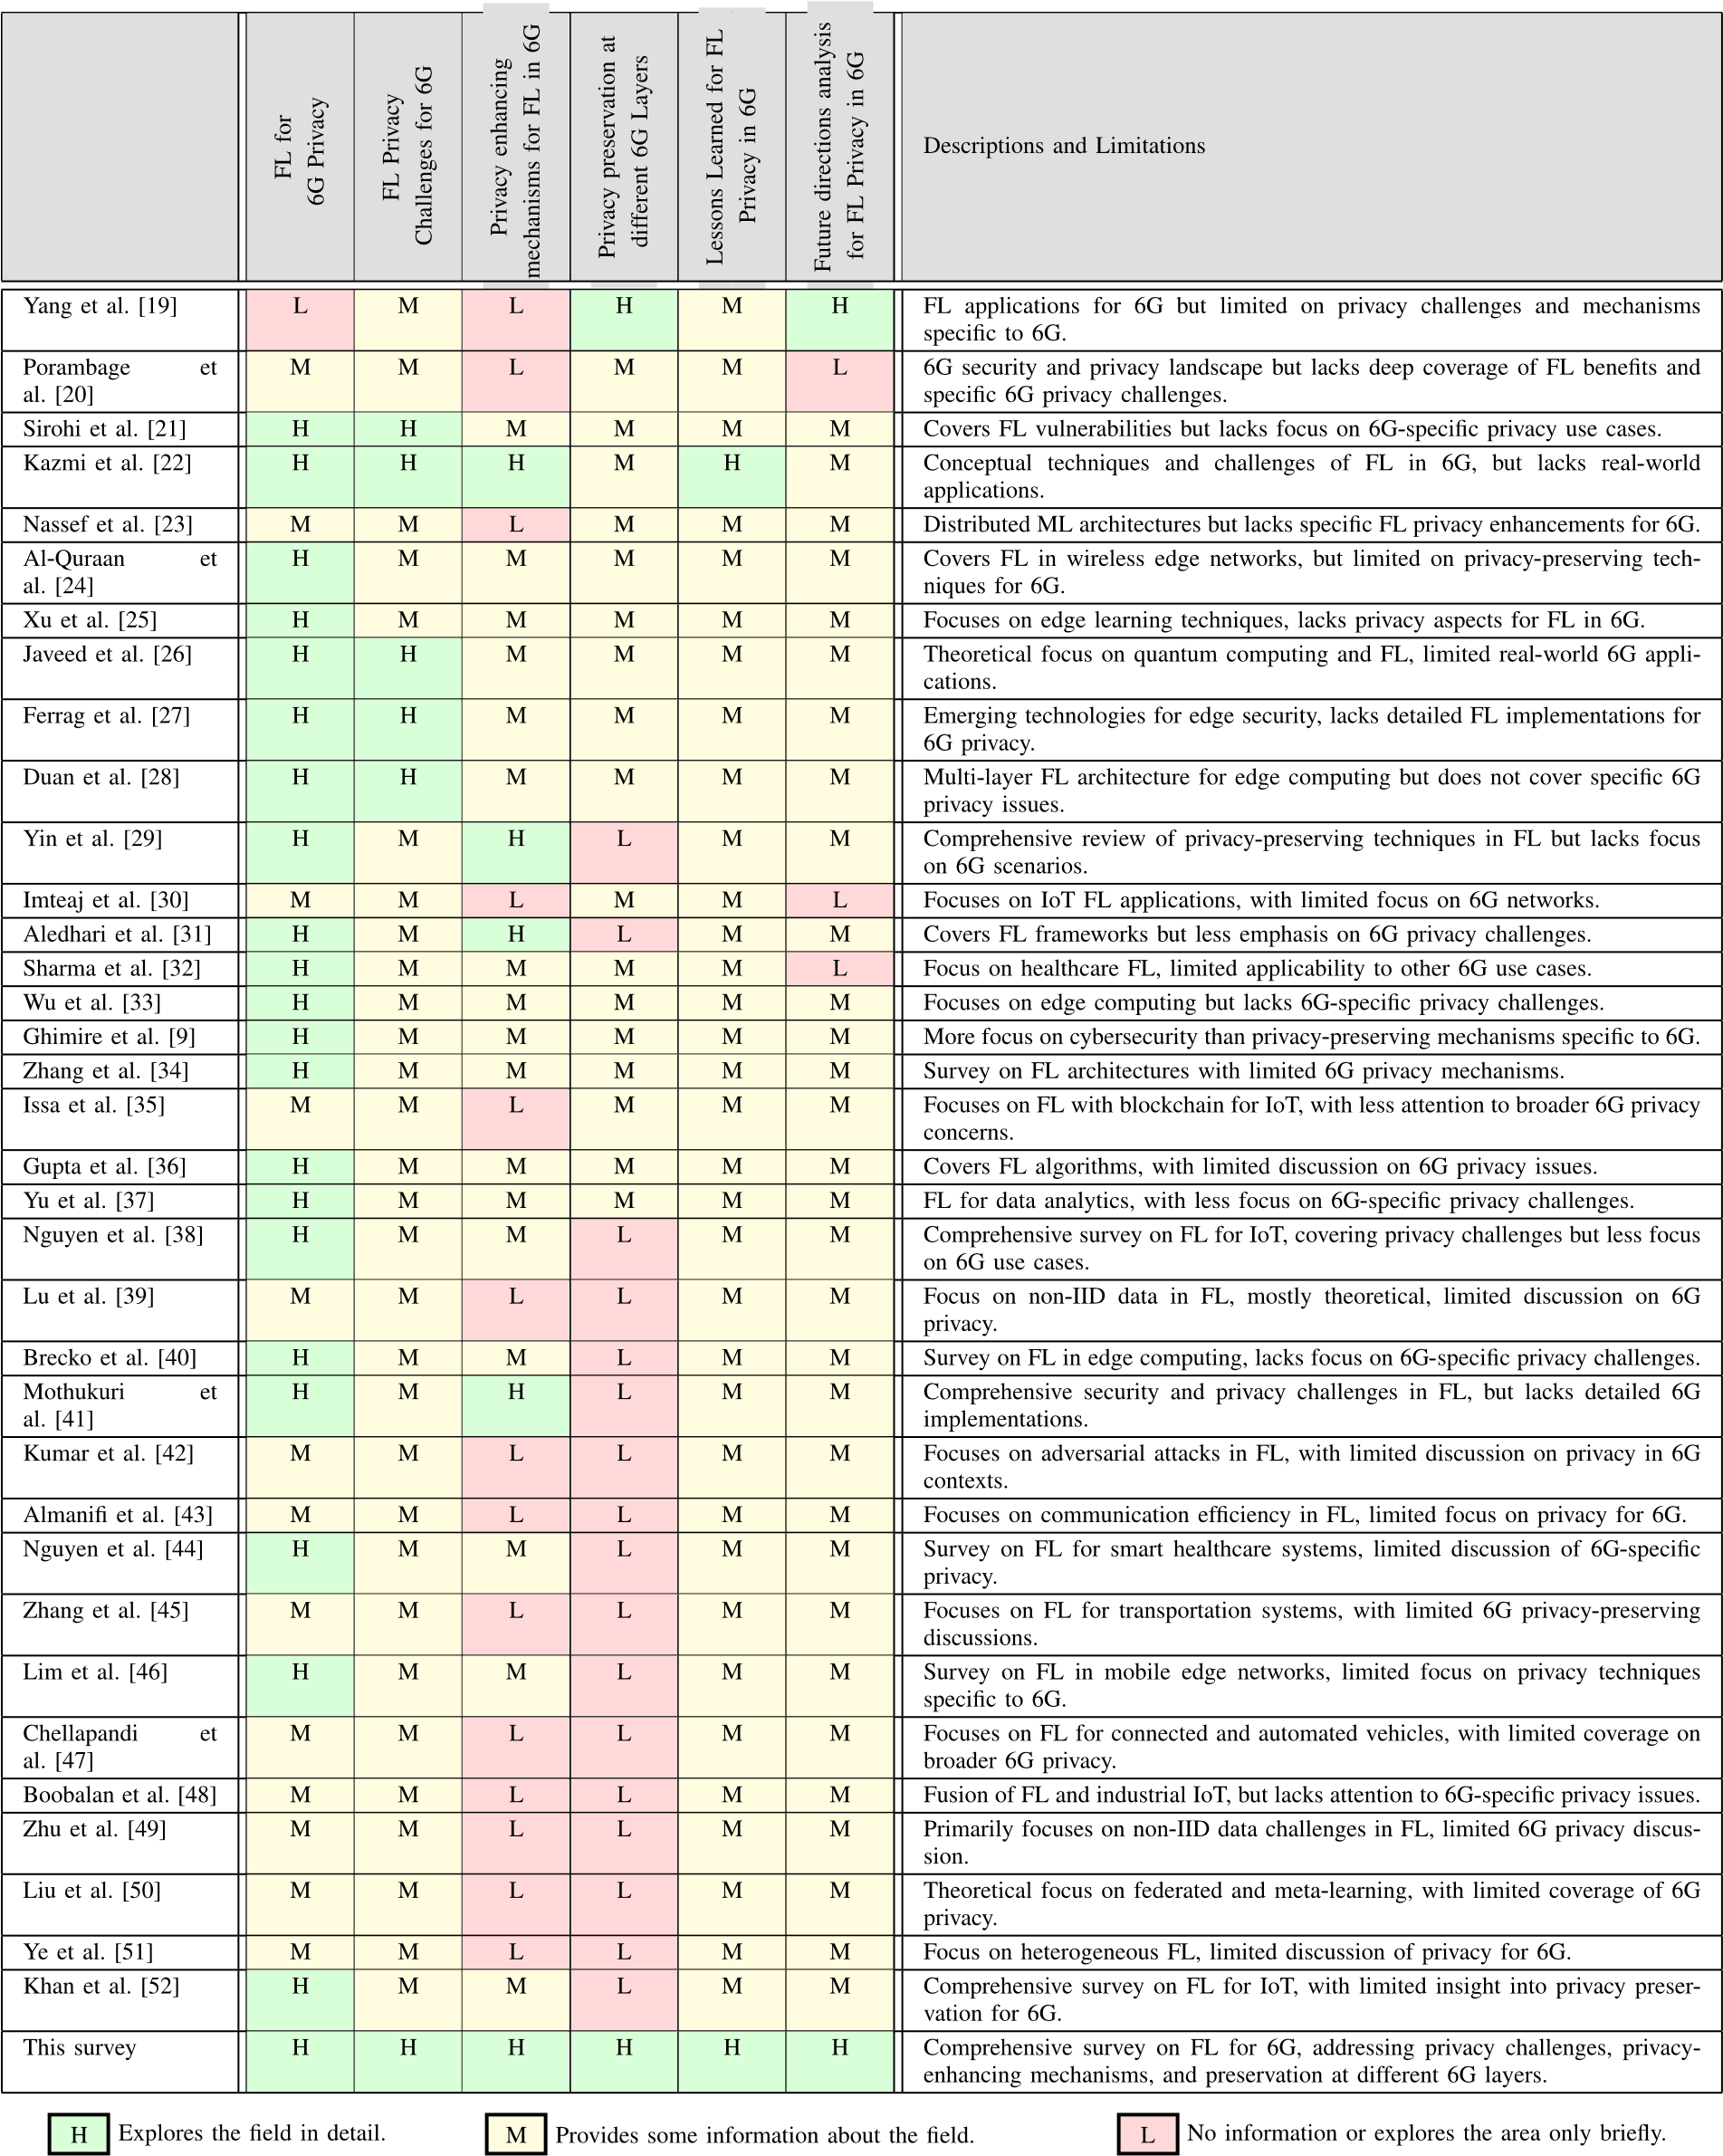
TABLE 2. Summary of important surveys on FL enabled security and privacy for 6G.
ML model while updating an FL server that runs a global ML model. It is different from DL as only model updates, such as gradients and model parameters, are shared with the FL server [7] in a manner that ensures the privacy of the end-user data. The FL server aggregates the information from the edge devices to update the weights of its model in an iterative manner [57]. FL enables network operators efficient resource allocation for different services [58], thus is envisioned to play an important role in 6G and other next-generation networks [59].
FIGURE 2. A conceptual illustration of FL.
FL can be classified based on network topology and data partitioning [38], [55], and it is illustrated in Fig. 3. Under network topology, FL can be classified as Centralized Federated Learning (CFL), Hierarchical FL, Decentralized FL (DFL), and Semi-DFL [52]. In CFL, each client trains its local model independently by using its own user data and transmits the model parameters to the FL server. These parameters are aggregated at the server using a weighted averaging algorithm, e.g., Federated Averaging (FedAvg) [7]. The global model is shared with all clients such that each client has a global model and a local model. Hierarchical FL utilizes several stages of aggregations at the edge servers in a hierarchical manner [60] before the final aggregation is done at the FL server. DFL is significantly different as it omits the requirement of a centralized server for orchestrating the learning process. The clients are nodes in a Peer-to-Peer (P2P) network, such that collaborative model training is possible [61]. Each client performs local model training and shares the model updates with its neighbors. The updates are aggregated at each node to reach a consensus on the global model update. Semi-DFL combines the advantages of hierarchical and decentralized FL [62]. It partitions the clients into several clusters, with a cluster head who is responsible for sub-aggregation in the respective cluster. Once the sub-aggregation is complete, the cluster heads collaborate in a decentralized manner to compute the global model. Again, a centralized server is omitted. This configuration reduces the communication overhead on individual nodes and mitigates the risk of singlepoint failures.
The classification based on data partitioning is related to how the training data is distributed over the sample and feature spaces. To this end, there are three main classifications, namely Horizontal Federated Learning (HoFL), Vertical Federated Learning (VFL), and Federated Transfer Learning (FTL) [5]. In HoFL, the clients share the same feature space, but they have different data samples. Hence, the same ML model can be used for local training [63]. The FL server aggregates the local updates to compute the global
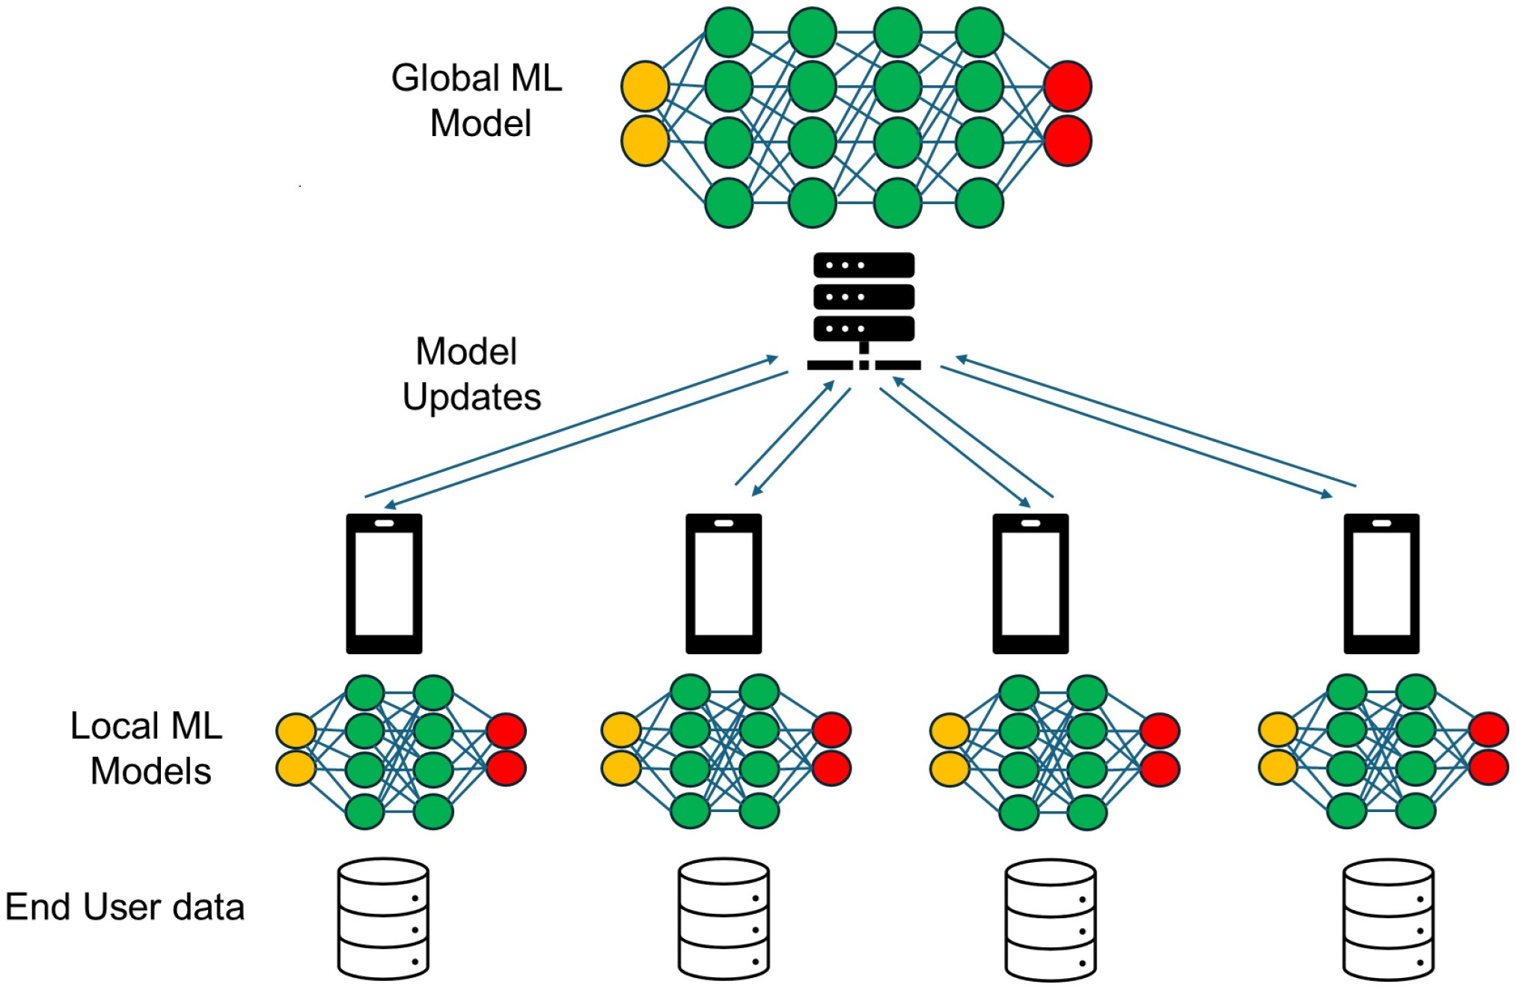
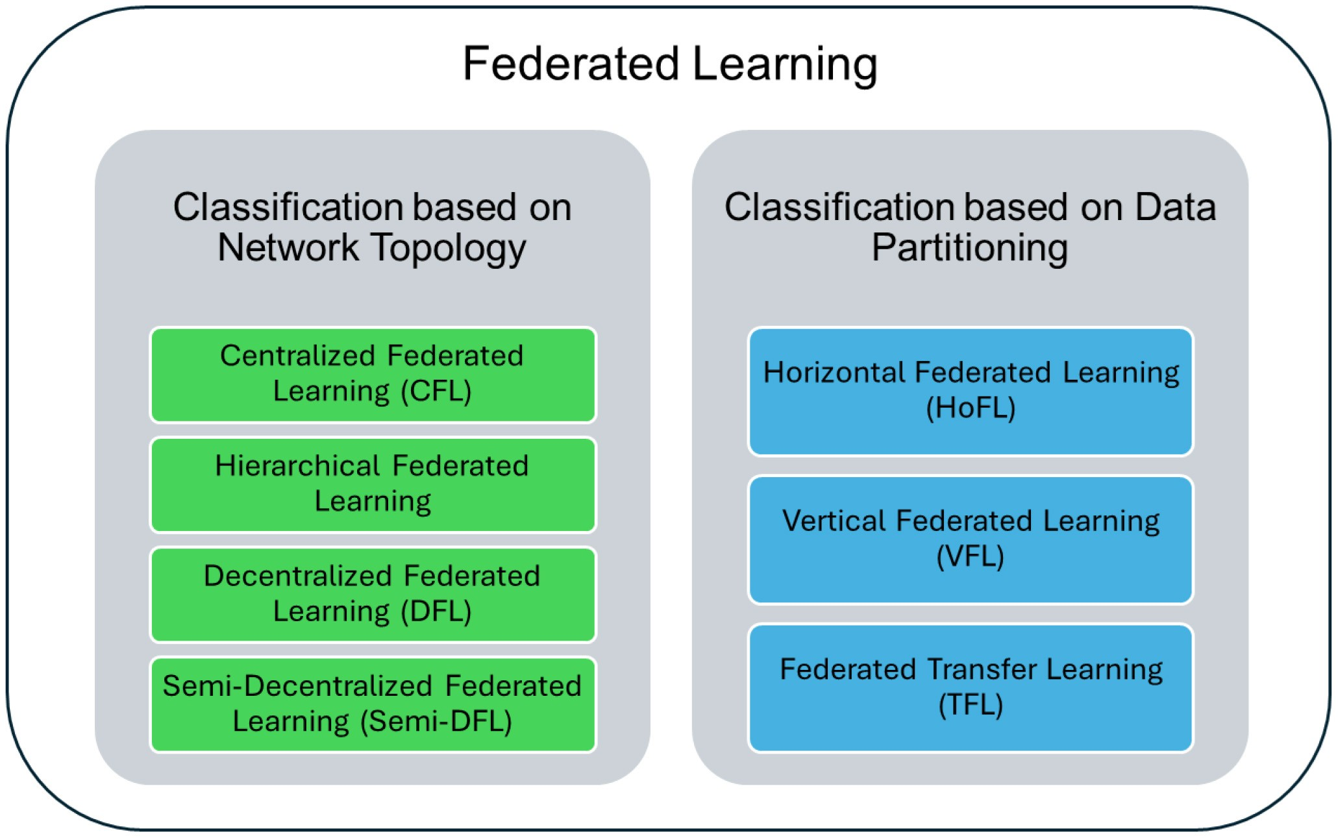
FIGURE 3. Federated learning classifications based on network topology and data partitioning.
update, which is shared with the clients as the basis for the next iteration of local training. For example, consider a smart city where various data acquisition devices are deployed [19]. These devices share the same feature space, such as weather data and traffic conditions, but they have different sample spaces because of their different locations and the tasks they carry out. VFL, on the other hand, caters to scenarios where the clients possess different subsets of features for the same group of samples [64]. Using a process known as entity alignment, the group of samples common to the clients is collected [65] and used to train a shared model while utilizing encryption for data privacy [66]. For example, consider the Intelligent Transportation Systems (ITS) realm. This setting may consist of various stakeholders with different data, e.g., vehicle manufacturers (data about the vehicles), traffic management authorities (data on road conditions, vehicle traffic, pedestrians), and telecommunication service providers (data on the connectivity of vehicles, drivers, and passengers). The sample space is the same as it is for vehicles/users, but the features are different [67]. These stakeholders can employ VFL to cooperatively train the models to predict traffic congestion, optimize route planning, or enhance the safety and efficiency of autonomous vehicles. This cooperation allows for the harnessing of collective knowledge, enabling more accurate and robust models while ensuring data remains with its original owner, adhering to privacy regulations. Finally, FTL is used in cases where both the feature space and the sample space are different among the clients [68].

B. ROLE OF FL IN 6G NETWORKS
6G networks consist of heterogeneous nodes that align with application scenarios and use cases of the industry verticals. The stringent Quality-of-Service (QoS) constraints in these networks in terms of speed and latency necessitate expensive computational operations to be offloaded towards the edge layer. This, together with the privacy concerns of user data, make FL an ideal candidate for 6G networks that inherently exhibit a distributed nature [69]. The relevance of FL in
TABLE 3. The relevance of FL to the 6G layers and the performance enhancements that can be achieved.
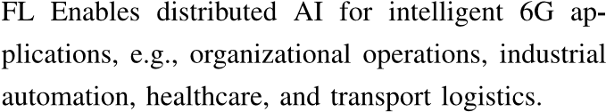
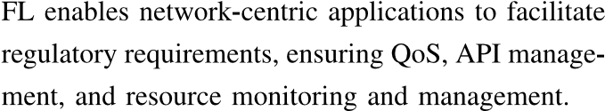
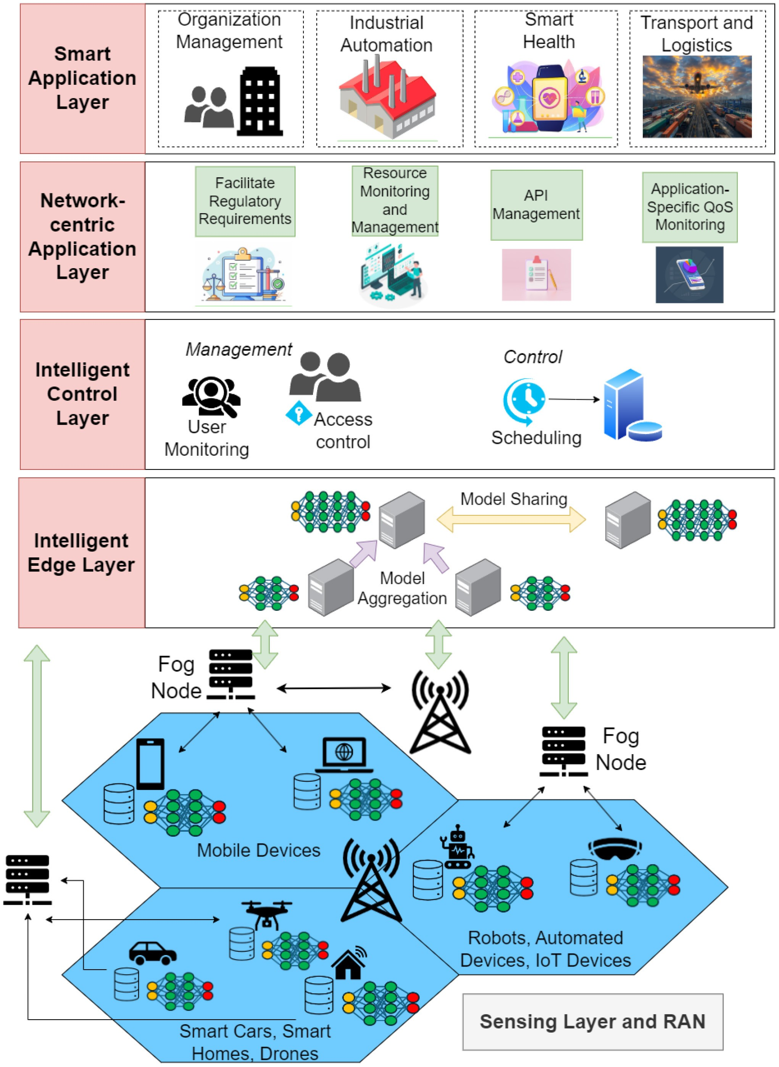
FIGURE 4. Role of FL in 6G networks.
related 6G layers (the Smart Application Layer, the Networkcentric Application Layer, the Intelligent Control Layer, and the Intelligent Edge Layer) is presented in TABLE 3. The Radio Access Network (RAN) supports connectivity and data collection through fog nodes, cell site connections, and connected devices, which include mobile phones, sensors, robots, IoT devices, and smart vehicles, as illustrated in Fig. 4.
Moreover, the usage of FL for model training introduces several key advantages in a 6G network [70]. These include privacy, low latency and overheads, and improved scalability. FL inherently preserves privacy as user data remains in its device, mitigating the risk of privacy breaches and unauthorized access in scenarios that involve sensitive data such as mobile traffic [2], [71]. This is crucial in a 6G network where data generation happens at high volumes at end devices. Eliminating the requirement to transmit these large volumes of data reduces latency [72], and hence makes FL an ideal solution for ultra-low latency applications. Devices learn a shared prediction model in parallel and in a collaborative manner with minimum interactions, thus significantly reducing the transmission overheads as model updates are typically much smaller in size compared to raw data [73], [74], [75]. This, in turn, reduces the energy consumption associated with data transmissions as well. Also, model training can be done continuously in a manner that is consistent with application-based timelines, and instantaneous decisions can be made at the end nodes. This will significantly facilitate applications that require real-time response, such as augmented reality, industrial automation, and autonomous driving [46].
FL also improves the scalability of a network. Firstly, FL stems on decentralized processing which distributes the processing over multiple nodes. This leads to a network that is easily scalable with an increasing number of devices. The system can leverage the computational resources of the new devices to enhance the model training efficiency of the overall network [2]. Secondly, the distributed nature supports managing heterogeneity and geographic distribution of data. In 6G, data is highly heterogeneous due to a diverse set of devices and applications. Thus, data distributions are unlikely to be identical. The local model training in FL facilitates this heterogeneity as models can adapt to the specific characteristics of the local data. Also, personalized models can be used to suit the data diversity among the devices. Heterogeneity can be considered in the data aggregation stage as well by clustering devices with similar data distributions and using weighted or adaptive aggregations according to importance or relevance. Selecting a subset of clients with similar data distributions for each training round can help stabilize the learning process and improve model performance. Moreover, regularization can be used to mitigate the impact of skewed data distributions during training. Incorporating data from varying geographical locations result in more robust and adaptable models that can cater a wide range of scenarios [5]. Finally, FL brings the model to the data, enabling ML in previously inaccessible environments due to legal, privacy, or logistical constraints associated with data protection. This significantly broadens the potential of ML-related applications in the future.
FL aligns well with the communication goals of 6G networks by improving communication efficiency, reducing latency, optimizing network resource usage, and supporting scalable and resilient network architectures. The reduced data transmission from FL alleviates network congestion and increases bandwidth efficiency. The frequency of model updates can be further adjusted to suit the network congestion similar to adaptive communication scenarios. Local training on the edge devices reduces the need for frequent, highlatency roundtrips to the centralized servers, which allows quicker response times for applications that rely on real-time data [76]. Such applications can be further supported by network slicing by assigning a specific slice optimized for low latency and high reliability. The feature of being able to support massive device connectivity (scalability) ensures efficient utilization of available computational resources. We also note that an FL-based communication network is more resilient and robust as the training process is distributed across multiple devices, avoiding single points of failure. Load balancing is supported, which reduces the risk of bottlenecks and improves the overall network stability. FL can also further enhance the user experience in applications where context-aware and personalized services are required. Thus, by integrating FL, 6G networks can achieve better communication performance and more effective utilization of available resources.
There are some important technical challenges in implementing FL in 6G networks, particularly in terms of hardware requirements and network infrastructure. Firstly, the edge devices need to be complex enough to support FL with sufficient computational power to train models. Training models locally on edge devices consume energy; thus, managing the energy consumption is critical [77]. Some edge devices may even depend on energy harvesting, so the usage of energy-efficient algorithms and hardware is vital in managing the tradeoff between complex and quick computations and energy conservation. Ensuring secure model updates through implementing advanced encryption techniques on resource-constrained devices also poses a significant challenge. The system should also be robust and adaptable to support the device diversity created by a multitude of edge devices with varying computational and storage capabilities, as well as communication interfaces.
The servers should be capable of handling high volumes of data for timely aggregation and updating the centralized models. Efficiently synchronizing updates from a diverse set of edge devices is challenging [78]. Verifying the integrity and authenticity of the model updates from these devices necessitates additional resources at the servers. Servers also require robust version control mechanisms to efficiently and accurately manage the frequent model updates.
There are several technologies that can facilitate FL in 6G networks. These include Multi-Access Edge Computing (MEC), SMC, FedAvg, Network Function
Virtualization (NFV), network slicing, Ultra-reliable Lowlatency Communication (URLLC), Edge Intelligence Frameworks, and Blockchain Technology [19], [79]. Adaptive protocols like Quick UDP Internet Connections (QUIC) and advanced versions of HTTP/2 that are designed for low-latency communication and efficient data transfer can also support the communication between edge devices and central servers to facilitate FL.
Next, we summarize some noteworthy contributions to using FL in 5G, B5G, and 6G networks. Firstly, we focus on the network topology-based classification of FL. To this end, authors of [70], [80], [81] have studied how CFL is beneficial in B5G and 6G networks. [80] proposes F-BIDS to protect the privacy of existing ML-based cyber-security. They use a centralized federated blending model, and the federated meta-classifier is trained on the meta-data instead of sensitive user data. The authors of [81] studied resource allocation in B5G networks using FL, particularly focusing on dynamic and heterogeneous network environments. In the literature on hierarchical FL, [82] consider hierarchical FL for 5G smart grids by proposing an intrusion detection system, and [83] consider wireless communication networks. The ability to use hierarchical FL to reduce the latency in a cellular network without losing the model accuracy is demonstrated in [84]. The method stems from clustering mobile users in the proximity of edge servers that communicate with a central server for global model aggregation. Similarly, a hierarchical FL-based solution for user assignment and resource allocation is proposed in [85]. The authors highlight the superiority of hierarchical FL over CFL with respect to training, communication overhead, accuracy, and speed.
The authors of [86] propose DFL-based traffic sign recognition in networked vehicles, and DFL for Vehicleto-Everything (V2X) networks for providing efficient distributed training services is studied in [87]. Furthermore, due to its inherent characteristics, P2P-based communication technologies such as blockchain can be easily incorporated in DFL systems [88]. In this scenario, information on model updates and aggregation can be communicated securely through blockchain ledgers. Furthermore, the performance of semi-DFL in B5G and 6G networks is studied in [89].
With respect to FL classification based on data partitioning, it is shown that Horizontal Federated Learning (HoFL) can utilize high-speed, low-latency communication infrastructure to share model updates between nodes, ensuring timely aggregation and dissemination [90]. Vertical Federated Learning (VFL) can also play a key role in B5G and 6G networks in enabling smart and interconnected systems across various sectors [91]. Federated Transfer Learning (FTL), which expands the possibilities of FL through collaboration, leverages the diversity and richness of data generated from different domains for enhancing the accuracy and robustness of the models [92]. FTL has been proposed as an efficient solution for intrusion detection for 5G IoT in [93].

III. FL FOR 6G PRIVACY
In this section, we discuss these potential applications of FL, including different domains of FL, potential challenges for FL in 6G, and how to enhance the privacy-preserving nature of FL for 6G by integrating other privacy-enhancing techniques. Although the concept of privacy is as old as mankind [94], in recent years, one can observe a modern emergence and discussion of privacy, especially with the introduction of regulatory approaches such as the European Union’s GDPR [95] in 2018. Privacy is generally the assurance that individuals have control or influence over what data about them may be collected and stored and by whom and to whom the information may be shared [96].
With the enhanced communication capabilities and seamless connectivity offered by B5G/6G networks, AI will play a dominant role in individuals’ everyday activities, making important decisions based on insights from big data collected from individuals. For these services to function smoothly, AI-driven automation of services will be a mandatory requirement for B5G/6G. For example, the number of attacks on 6G-based services will increase significantly with the enablement of ultra-high communication speeds and the ubiquitous availability of access points and IoT. Therefore, it will not be possible to manually manage the security of these services. Automating the proactive detection and remediation of attacks, therefore, requires AI-driven approaches [97]. However, the requirements for the protection of privacy also apply in the areas of future communication and AI. In the previous example, the AI applied in 6G could be a double-edged sword, as the continuous monitoring of user traffic by these AI models can create a new attack surface for end users and service providers. With advances in the interpretation of big data and advances in AI facilitated by fast communication techniques, the controllability, transparency, and ownership of data from end users, organizations, and states are increasingly being challenged. This issue may become more significant in future B5G/6G network infrastructures as the ability to collect and analyze user data will continue to increase with the support of AI-driven services.
The leakage of unintended information through B5G/6G services can be a critical privacy issue as it directly affects users’ rights and control over their data. For example, a smart light connected wirelessly via B5G/6G to a remote server or smart device can increase the energy efficiency of the home. At the same time, however, it can also collect data, e.g., when a user is at home, which rooms are frequently used, and whether there are people in the house. This can then provide insights into the user’s habits, preferences, and daily routine [98]. Therefore, the AI-driven 6G applications combined with the expanding IoT layer to sensitive personal data drastically increase the possibility of identifying information about individuals such as their health status, current actions, prediction of decisions, movements, interests, personal beliefs, ideologies, etc. Applications can analyze the data output via sensors, smartphones, and other personal electronic devices with a network connection. Third parties can collect a wide range of signals and extract this information from the individuals/users concerned.
The key privacy requirements that 6G should satisfy come from multiple technological advancements that 6G possess compared to previous network generations. We can list them as follows:
- AI-based zero-touch automation: This new progression of network management via AI reduces the delays in establishing communications and the need for human intervention to the network. Zero-touch management promotes distributed ML operations like FL to automatically perform AI model training, collaboration and sharing of models [99]. However, it also creates a major requirement of ensuring the privacy of the models shared over the network. Furthermore, if these shared AI models used in zero-touch management networks consist of vulnerabilities like backdoors or triggers, it will increase the risk of privacy leakage, potentially revealing network patterns or sensitive network-related information such as periodic data or patterns of data usage.
- Massive connectivity of sensors and smart user devices: Unlike the previous generations, a surge of new devices like IoT, along with the improvements in the edge AI and lightweight local computation hardware, the upcoming 6G networks will have billions of local devices interconnected wirelessly and collaborating with each other. Thus, privacy requirements are of high importance, considering the relatively less secure communication protocols and encryption mechanisms in these relatively limited resource IoT devices. Furthermore, transmitting data in a more secure manner requires higher computational and energy demand for operations like authentication [100]. Therefore, keeping the data locally for the device without forwarding them to third parties is more favourable for IoT, which is achieved via FL.
- Location and movement privacy requirements: In 6G, with the proliferation of billions of new devices and increased localization accuracy, there is a heightened risk of location-based privacy breaches. Highly accurate location tracking could allow adversaries to map individuals’ movements or sensitive location data. 6G networks need privacy-preserving ML techniques to train the models containing these location data safely. Furthermore, communication systems like V2X [101] will be further enhanced by the mobility and high bandwidth provided by the 6G networks, facilitating real-time communication among these smart vehicles. Thus, FL can enable training and knowledge sharing among them in a privacy-preserved manner.
- Privacy in Immersive Applications: 6G will enable highly immersive applications such as Augmented Reality (AR), virtual reality Virtual Reality (VR), and Extended Reality (XR) beyond the current limitations due to its capability of establishing massive connectivity and ultra-high data rates. These applications will generate vast amounts of sensitive user data, including biometric information, personal behaviour patterns, and interactions within virtual environments. Current research has already investigated numerous privacy vulnerabilities in devices like VR headsets, such as unrestricted motion, optical and eye-tracking sensors, which could be exploited by an adversary [102]. Protecting this sensitive data from being exposed or misused is a major privacy requirement. Thus, FL can support in enabling privacy-preserved distributed metaverse intelligence.

A. SUPPORT OF FL FOR IMPROVED 6G PRIVACY
FL can improve privacy in 6G communications in several ways. Some of them are summarized in below items:

1) DATA DECENTRALIZATION
In traditional ML, the data for training is collected and stored centrally. In FL, however, the models are trained directly on the devices on which the data is generated (e.g., smartphones, IoT devices), which ensures that the raw data never leaves the device. In 6G networks, where huge amounts of sensitive data are generated and transmitted, the decentralization provided by FL is crucial. By keeping the data local, FL reduces the risk of data breaches and unauthorized access, as there is no central repository for sensitive information to be targeted by attackers. In a 6Genabled smart healthcare system, for example, patient data remains on wearable devices, maintaining confidentiality while contributing to a global healthcare model [103].

2) MODEL AGGREGATION
FL typically employs secure aggregation protocols where individual model updates (not the raw data) are sent to a central server. These updates are combined to improve the global model. For example, in smart city applications with FL, traffic pattern data can be used to optimize urban mobility without compromising individual commuter privacy [104]. Techniques such as DP can be applied during the aggregation process to add noise to the updates, further obscuring individual data contributions and protecting user privacy [105]. This is particularly important in 6G networks, where the integration of extensive and diverse data sources increases the risk of identifying individuals based on their data patterns.

3) COMMUNICATION EFFICIENCY
To minimize communication overhead, FL often uses techniques to compress model updates before sending them [106]. This not only reduces the required bandwidth but can also include privacy-preserving transformations. This is important in 6G networks as large amounts of data are generated by numerous connected devices.

4) SECURITY
FL updates can be encrypted during transmission, ensuring that even if intercepted, the data remains secure and unintelligible to unauthorized parties [107]. In this respect, the security framework of 6G can be complemented with encrypted FL to address various vulnerabilities, including threats to confidentiality, integrity, and availability. In MEC scenarios of 6G networks [108], for example, where data processing takes place at the edge of the network, i.e., closer to the devices, encrypted data transmission in FL enables collaborative learning on this distributed data while keeping it private. FL can also be used for intrusion and anomaly detection in 6G networks to address privacy concerns and improve security in distributed environments. As 6G brings higher device density, diverse network components and increased real-time data requirements, FL-based intrusion detection offers scalable and secure solutions in areas such as Software Defined Networking (SDN), Industrial Internet of Things (IIoT), Cyber-Physical Systems (CPS) and Vehicular Edge Computing. Each of these areas offers unique challenges and opportunities.
Li et al. [109] presented an efficient FL system for network intrusion detection, focusing on reducing communication cost and improving model accuracy, important considerations for high speed and low latency requirements in 6G networks. Raza et al. [110] extended this idea within SDNs, where FL enables privacy-preserving detection without transmitting sensitive network data. Their model is particularly relevant to 6G due to the inherent programmability and scalability of SDNs, which enable more responsive and adaptive intrusion detection mechanisms. Similarly, Chatzimiltis et al. [111] presented a collaborative SDN-based intrusion detection system tailored for smart grids, an area where the interplay between low-latency 6G communication and high security is crucial to ensure infrastructure resilience. Bhavsar et al. [112] used FL in transportation IoT to facilitate intrusion detection in distributed IoT devices to ensure privacy protection while improving the robustness of transportation networks, an important aspect as 6G increases the number of connected vehicles and devices in smart cities. Huang et al. [113] addressed the specific requirements of CPS and proposed Execution & Evaluation dual network framework, a dualnetwork FL framework that personalizes intrusion detection based on device characteristics, which aligns well with the need for tailored security in the various application domains of 6G.
Recent advances have further enhanced FL’s intrusion detection capabilities by integrating blockchain to secure FL processes through decentralized trust models, which are essential for combating intrusions in highly dynamic and distributed/decentralized environments such as 6G networks. For example, the framework presented in [114] utilizes blockchain to support federated learning for intrusion detection in vehicle edge computing. This approach improves collaboration and anti-tampering protection across distributed vehicles and enables 6G networks to support a secure vehicle ecosystem. In addition, [115] presents a privacy framework that specifically targets jamming attacks and uses FL to jointly detect and mitigate these attacks. This approach is critical for 6G, as maintaining signal integrity is essential for services that require ultra-reliable low-latency communication (URLLC). Authors in [116] build on this by combining FL with explainable AI and blockchain.
This creates a robust intrusion detection system for IoT networks that can ensure both privacy and transparency. Such integration is essential for 6 G’s multi-layered security requirements to ensure that the decisions made by the model are understandable and trustworthy for end users. In addition to these frameworks, recent research has explored the intersection of FL with quantum technologies. The paper in [117] proposes a quantum federated learning framework to protect privacy in detecting intrusions into consumer networks. By leveraging the potential of quantum computing for robust encryption, this framework adds an additional layer of security to intrusion detection, addressing the challenges of processing large, sensitive consumer data in 6G networks. Such integration of quantum technologies with FL is critical as it holds promise for overcoming computational and privacy constraints, especially as 6G brings unprecedented amounts of data and diverse devices to the network. The integration of FL with reinforcement learning ([118], [119]) has also been investigated to combat specific attacks such as jamming, which are crucial for secure and reliable 6G communication in wireless sensor networks and open radio access networks.
In summary, the above studies show that FL, supported by blockchain, quantum technologies and advanced AI techniques, provides a flexible, privacy-preserving, and robust framework for addressing the evolving security challenges of 6G. Each domain-specific application illustrates how FL can be adapted to the unique requirements of 6G environments, paving the way for more resilient and responsive security mechanisms in next-generation networks.

5) INTEGRATION OF PRIVACY-PRESERVING MECHANISMS
Homomorphic encryption allows calculations to be performed on encrypted data without decrypting it. In FL, it can be used to enable the central server to aggregate model updates without accessing the underlying data [120]. In the context of 6G, this means that sensitive data from industrial IoT devices can be processed securely, ensuring operational confidentiality. SMC allows multiple parties to jointly compute a function over their inputs while keeping those inputs private. In FL, this can be used to aggregate updates without revealing individual updates to the central server or other parties [121]. As 6G is expected to support a wider range of applications, potentially including more sensitive data, SMC‘s strong data privacy protection guarantees during the FL process will be crucial in such scenarios.

6) AUDITABILITY AND TRANSPARENCY
FL frameworks often include mechanisms (e.g., blockchain) for auditing data access and use to ensure transparency and traceability regarding the use and sharing of data [18], [122], [123]. This is critical to maintaining user trust in 6G applications where data privacy is paramount. In addition, the users or the owners of the application in an FL setup usually have more control over their data as they can opt in or out of the learning process, decide what data they want to contribute, and have a clearer understanding of how their data will be used [124]. This can build trust and ensure user privacy. Coupled with 6G’s low latency and edge computing capabilities in real-time AI applications for smart cities, citizens can decide for themselves whether their anonymized location data or sensor data from their homes will contribute to the training of AI models for city management.

7) ROBUSTNESS AGAINST KNOWN PRIVACY ATTACKS
FL in 6G networks must address a wide array of sophisticated privacy threats to ensure secure and trustworthy communication frameworks. FL can incorporate anonymization techniques to ensure that updates are not linked to specific users, reducing the risk that data can be traced back to an individual. In this regard, a human-centered 6G communication framework equipped with FL can play an important role in such efforts to prevent the frequent disclosure of data and improve users’ lives in terms of privacy [125]. Beyond anonymization, FL models can also be designed to be robust against adversarial attacks, such as model poisoning or inference attacks, which further enhances the privacy and security of the data [126]. However, a more thorough investigation of privacy threats is essential for a robust FL framework in 6G. Attacks such as Byzantine attacks, where adversarial participants send misleading model updates, require robust aggregation algorithms that prevent compromised nodes from corrupting the model [127]. Robust aggregation techniques such as Krum and Bulyan are crucial to mitigate the impact of such attacks and ensure that malicious contributions are effectively detected and excluded [128]. The robustness of aggregation algorithms is, therefore, crucial for the security of FL, especially in dense 6G environments where malicious actors can exploit vulnerabilities in model aggregation to skew the model outputs.
Another key threat in 6G FL frameworks is manin-the-middle attacks on model updates, where an attacker intercepts and alters updates between devices and servers [126], [129]. To ensure the confidentiality and integrity of model updates, secure channels, encryption and continuous verification of model integrity during the update process are required. Techniques such as differential privacy and homomorphic encryption can provide further protection against such attacks and make it more difficult for unauthorized parties to modify or intercept sensitive data in transit.
Fig. 5 provides a high-level overview of how FL techniques can be used to enhance privacy in 6G networks to address these vulnerabilities. By incorporating these strategies, FL can provide a robust framework that maintains improved levels of privacy and security while enabling the benefits of collaborative learning across distributed data sources. We further discuss these privacy-enhancing
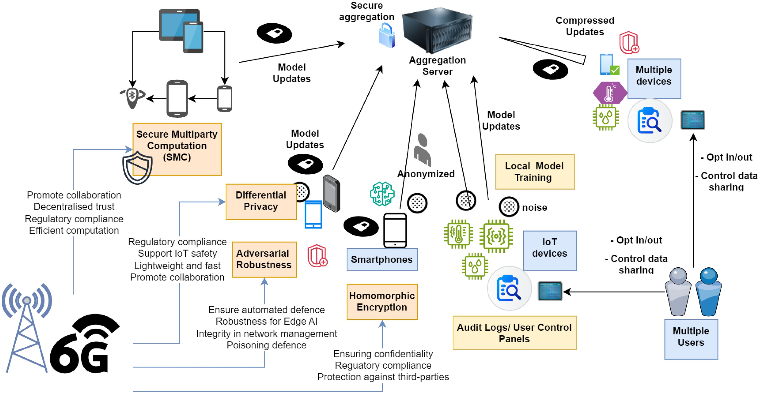
FIGURE 5. FL for enhanced privacy in 6G networks, illustrating the key components and privacy-preserving mechanisms that ensure secure and efficient data processing in a
6G environment.
techniques and their current improvements to be done in Section V.

B. 6G USE CASES WITH IMPROVED PRIVACY THROUGH FL
FL can be used to significantly improve the privacy of 6G networks by enabling the decentralized training of ML models in various 6G use cases. For example, 6G networks can support advanced health monitoring systems with extreme Ultra-Reliable Low-Latency Communication (xURLLC) [130] or real-time holographic communications [131]. In smart health, wearable devices can collect health data such as heart rate and blood glucose levels [132]. FL with 6G connectivity enables these devices to collaboratively and rapidly train a large model that can predict health anomalies without sharing the raw data, thereby preserving data confidentiality. This ensures that personal health data is not disclosed or transferred and that patient privacy is protected. 6G’s ability to connect numerous devices at high data rates and low latency makes it ideal for smart city applications [133]. In smart cities, traffic sensors and connected vehicles can collect data about traffic patterns sent within 6G networks. With the help of FL, these devices can jointly train models to optimize traffic flow and reduce congestion without sharing individual travel data, thus preserving commuters’ privacy [134].
6G networks have the potential to revolutionize industrial automation by connecting machines, sensors, and control systems with high reliability and low latency [135]. In industrial automation, machines on a production line can use their operating data to train models that predict failures or maintenance needs. With FL, each machine contributes to the model without revealing its data, thus preserving the confidentiality of industrial processes [136]. 6G networks will support autonomous vehicles with high data and ultra-low latency requirements for the safe operation of autonomous vehicles [83]. In intelligent vehicles, autonomous cars can collect data on driving behavior and road conditions. FL enables these cars to train models that improve navigation and safety systems while ensuring that individual driving data is not shared to protect user privacy [137].
6G networks will connect a variety of IoT devices in smart homes, from appliances to security systems [138]. FL helps these devices to improve their algorithms locally and ensure data privacy [139]. In IoT and edge devices, devices such as smart thermostats and security cameras can use FL to improve their algorithms for energy management and security threat detection. In the field of smart home security, for instance, cameras and sensors can use FL to develop more accurate intrusion detection models by learning locally from the data. This can ensure that personal video recordings and sensor data are not transmitted to central servers and that the privacy of the household is maintained. Each device can process its data locally and only share model updates, so no sensitive household information is exposed. The high bandwidth and low latency of 6G networks can enable these devices can share model updates quickly and efficiently [27].

C. PRIVACY THREATS AND ENHANCEMENTS IN 6G NETWORKS
In 6G networks, the adoption of cutting-edge technologies and architectural changes brings about a new set of privacy challenges, distinct from those seen in earlier generations like 5G. Some of the key features of 6G, such as intelligent surfaces, pervasive AI, massive Machine-Type Communications (mMTC), and the utilization of terahertz (THz) frequencies, present novel vulnerabilities that demand specialized privacypreserving mechanisms.
One of the most important threats to privacy in 6G comes from Ultra Dense Networks (UDNs). With an unprecedented density of devices, the resulting complex architecture increases the number of potential vulnerabilities. Extensive data exchange in this dense environment increases the risk of data breaches and offers attackers more opportunities to intercept, manipulate or misuse sensitive information. In addition, the use of THz bands in 6G, while beneficial for high data rates and low latency, introduces new risks at the physical layer. These high-frequency signals are more susceptible to eavesdropping, jamming and interference, making it easier for unauthorized parties to access or disrupt communications. Pervasive AI integrated into 6G networks, especially in edge computing environments, poses another significant privacy concern. The role of AI in data collection, processing and decision-making increases vulnerability to sophisticated attacks, such as model inversion and membership inference attacks, where sensitive user data can be derived or extracted from AI models. In addition, 6G networks are expected to integrate multiple communication layers – including satellite, aerial, and terrestrial components – forming spaceair-ground networks. The transmission of data across these heterogeneous infrastructures, each with different security protocols, introduces additional vulnerabilities, particularly during the transition between less secure nodes. mMTC in 6G, which is characterized by the connection of billions of IoT devices, further complicates privacy management due to the decentralized nature of these devices. The aggregation of data from such a large number of sources increases the risk of data breaches and unauthorized use. These threats will be intensified by the expected arrival of quantum computers in the 6G era. These could render many of the cryptographic techniques currently used to protect privacy in wireless networks obsolete.
Despite these threats to privacy, the advanced features of 6G can be used to enhance privacy protection. For example, several real 6G use cases such as tactile Internet, real-time holographic communications, XR/multi-sensory communication, massive digital twin networks, and remote surgery with haptic feedback introduce new dimensions for privacy enhancement through FL. The tactile Internet in 6G, which supports ultra-low latency and real-time haptic interactions, poses a challenge for privacy. However, FL ensures that sensitive haptic feedback data is processed locally so that personal data remains secure. In real-time holographic communication or telepresence, where large amounts of 3D holographic and motion-capture data are exchanged, FL enables local model updates without the need to exchange raw holographic data, thereby enhancing privacy [134]. XR and multisensory communication require multi-gigabit speeds and ultra- low latency. Here, FL can protect user privacy by keeping the immersive experience data on local devices while still sharing useful insights [140]. Massive digital twin networks collect huge amounts of operational data from multiple sources. FL’s decentralized training enables companies to leverage these networks without exposing sensitive operational data to external threats [141]. Remote surgery with haptic feedback benefits from FL by ensuring that highly sensitive surgical data, including both haptic and visual information, remains private while enabling collaborative improvements in surgical procedures [142].
Moreover, pervasive AI can be used for real-time anomaly detection and adaptive privacy policies. By intelligently managing privacy settings based on context, user location and application type, AI can dynamically adjust protections to strengthen privacy. The decentralized architectures supported by 6G, such as blockchain, provide robust and transparent data management that ensures secure storage and traceability of sensitive information and reduces the risk of unauthorized access. Intelligent Reflecting Surfaces (IRS), another key feature of 6G, can improve physical layer security by dynamically controlling the radio environment. This capability helps to mitigate eavesdropping attempts and strengthen the security of communication links. Furthermore, the inclusion of quantum communication technologies, in particular Quantum Key Distribution (QKD), provides an additional layer of security as QKD generates encryption keys that cannot be intercepted or decoded without detection.
Finally, Table 4 summarizes how FL improves privacy in various 6G use cases, leveraging the specific capabilities of 6G networks.
IV. KEY FL PRIVACY CHALLENGES IN 6G NETWORKS The section explores key privacy challenges in B5G/6G networks. This includes the issues that occur within the training process, communication, and storage of data and models in FL and where these FL issues occur at the 6G architecture.
As 6G networks emerge, they introduce new privacy challenges compared to 5G, especially in the context of FL. These challenges arise from the larger scale of devices, more sensitive and diverse data sources, and the need for realtime processing. Table 5 highlights key privacy challenges in FL for both 5G and 6G networks, illustrating how the complexities grow with the transition to 6G.
Next, we discuss specific issues in the FL lifecycle and how each of these challenges are applicable when performing FL operations in 6G architecture.

A. PRIVACY ISSUES WITHIN THE MODEL TRAINING PROCESS LIFE-CYCLE
Though FL appears to be a promising future for Privacy Preserved ML (PPML) in 6G, there can be potential privacy leakages via FL itself. Fig. 6 provides an overview of how

TABLE 4. 6G use cases and privacy enhancements with federated learning.
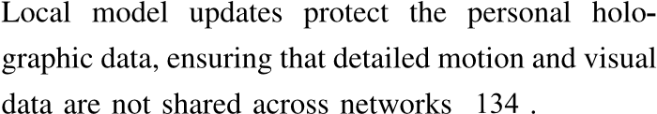
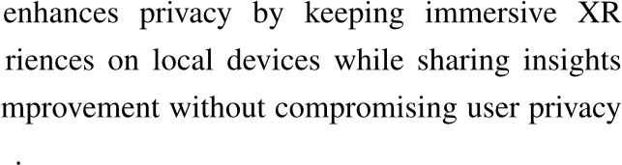
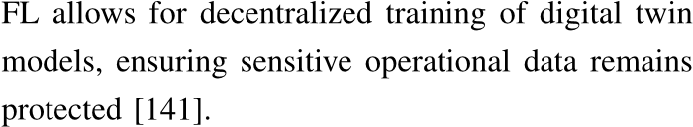
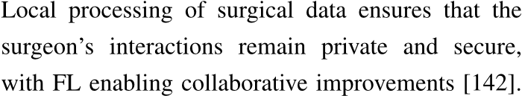
TABLE 5. Comparison between 5G and 6G FL challenges.
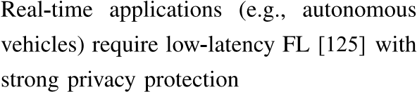
the FL process occurs in the B5G/6G architecture, and the 1) MODEL MEMORIZATION
vulnerability of the process to privacy threats. We outline Although data is not directly transmitted from the client, the following challenges arising from FL that can impact they still have to transmit model parameters trained on
B5G/6G privacy: each client’s private data. Such parameters can consist

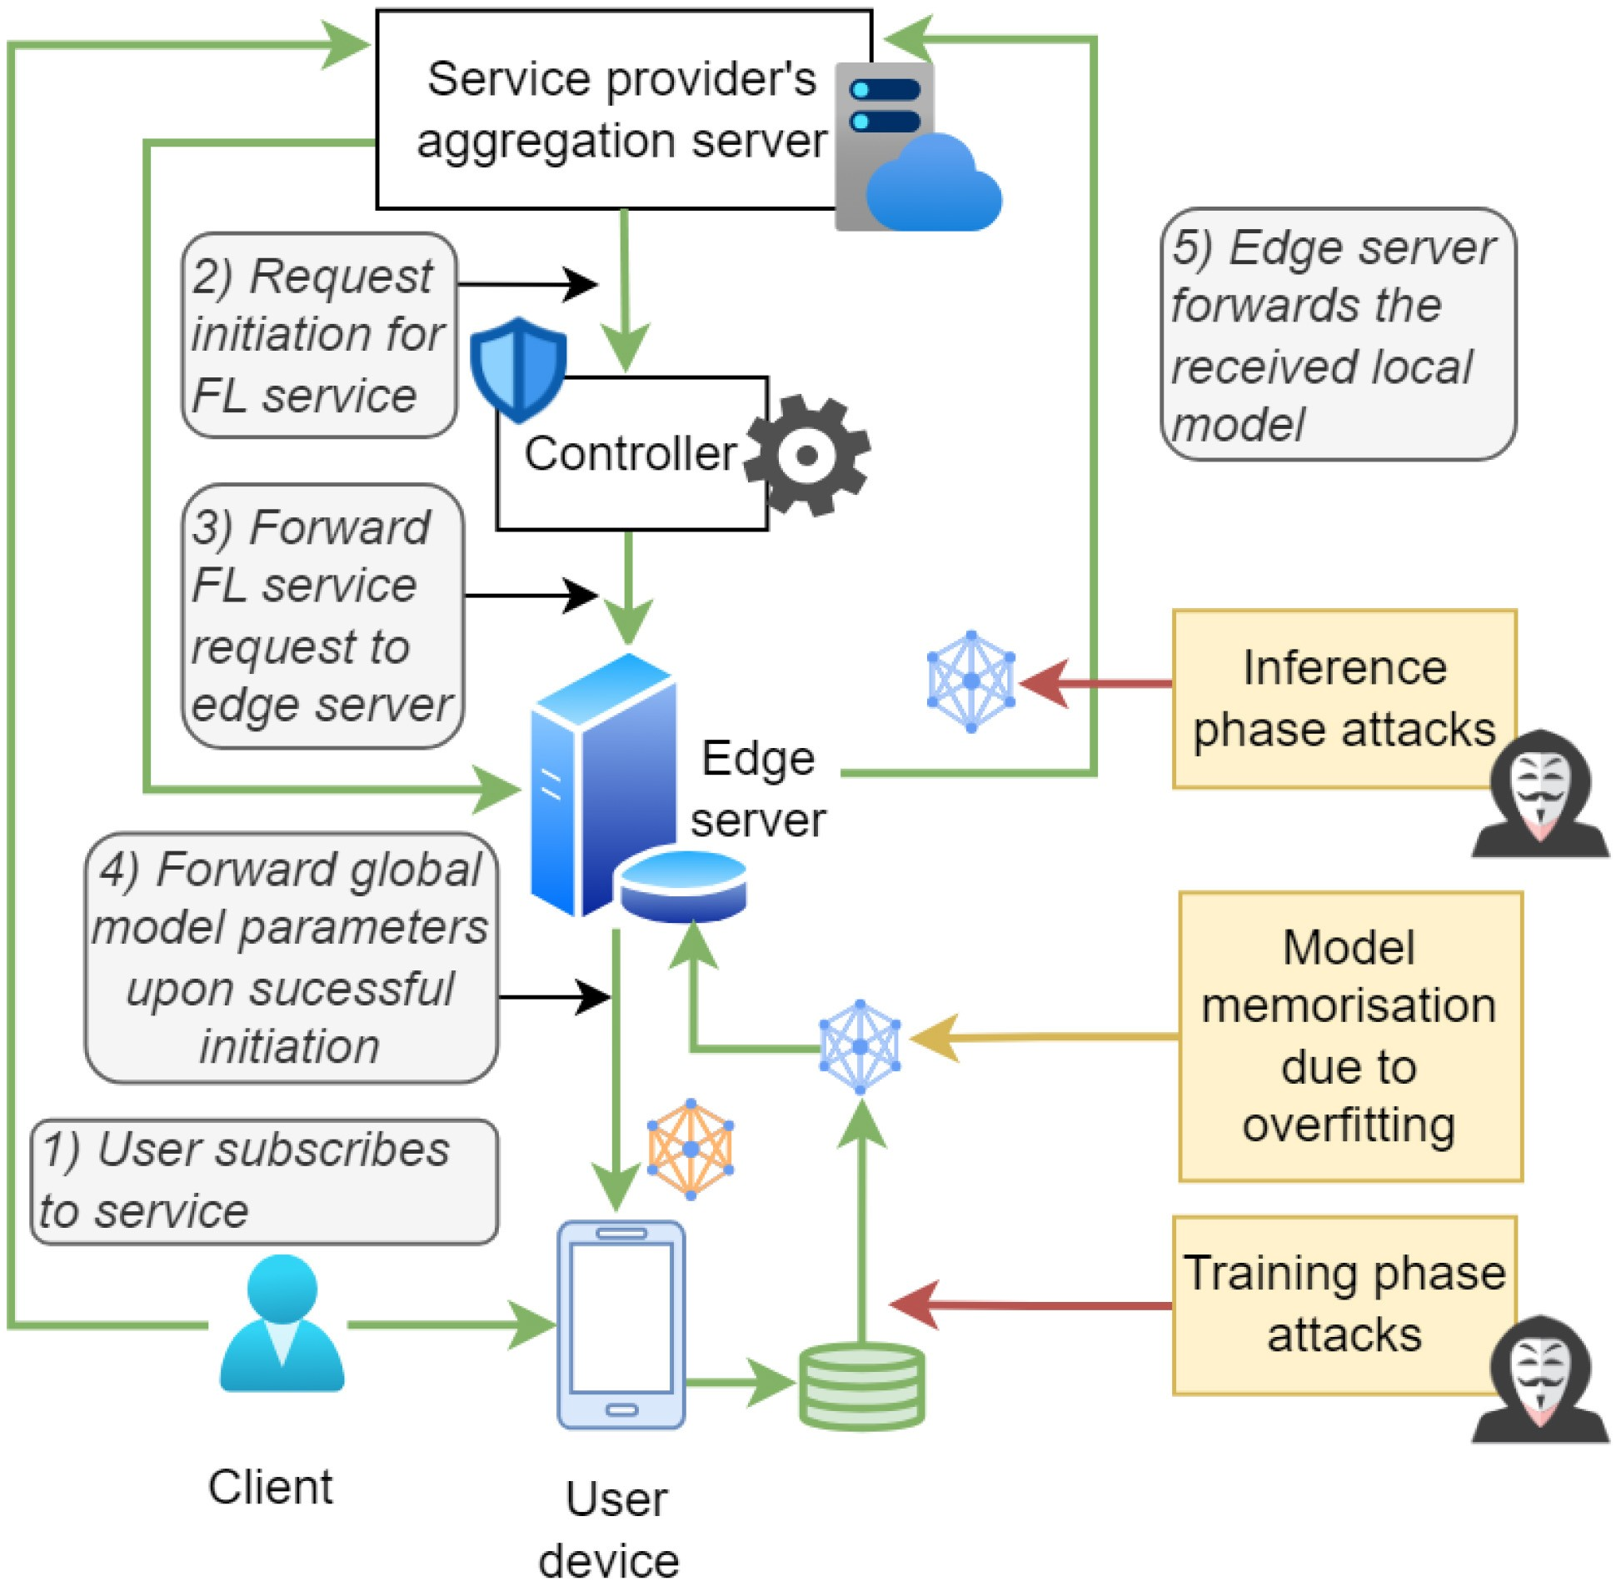
FIGURE 6. Overview of FL services and related privacy issues in FL during the process.
of insights that may be indirectly related to the original data [145], [146], making the models memorize information about the user data. Thus, adversaries can exploit these model parameters to reveal unintended information on data owners. In B5G/6G, when end users communicate models related to private and sensitive information they locally possess, an external party at higher layers could eavesdrop on these model updates to look for potential properties that can reveal the original data.
In 6G networks, the massive scale of data and real-time applications like autonomous vehicles [147] and metaverse [148], [149] heightens the risk of model memorization. It can unintentionally retain sensitive information from the training data. This makes it vulnerable to privacy attacks. Compared to 5G, 6G’s increased data diversity and criticality, such as healthcare, BCIs [150] amplify privacy concerns, as more sensitive personal data could be exposed through model leakage across distributed nodes.
Recent research on FL privacy shows that FL is vulnerable to numerous privacy attacks, including reconstruction, model inversion, membership inference, and property inference attacks [41], [145]. These attacks can be categorized into two [151]: training phase attacks and inference phase attacks.

2) TRAINING PHASE ATTACKS
Considering the training phase, we can identify attacks such as backdoor poisoning. Since FL is based on many client devices collaborating together, a malicious client has the potential to inject model updates that are biased towards a certain property, causing backdoors in the aggregated model [152]. Sybil is another attack [151], which seeks to simulate numerous end devices without interfering with the FL protocol. An attacker may also try to eavesdrop on the model updates during transmission to the aggregator by a particular client, even though the adversary does not have access to the client data or the aggregator. All these attacks can mainly happen at the local device layer of B5G/6G. However, during transmission, an attacker can also launch a man-in-the-middle attack such that they can forward malicious data or perform eavesdropping at upper layers.
Gradient leakage attacks are another main attack type [153] that exploits the gradients shared by clients to reconstruct sensitive training data. By analyzing these gradients, attackers may attempt to fully or partially recover the private training data of the clients. In free-rider attacks, malicious clients avoid contributing meaningful data or computation while still benefiting from the collective model, which can be commercially valuable or highly sensitive to user data [154]. Another key concern is model stealing during training, where adversarial clients attempt to steal the ownership of the client models, their contributions and watermarks [155].
In 6G, the large-scale, decentralized nature of networks with massive IoT devices, edge computing, and critical applications such as healthcare and autonomous systems increases the risk of training phase attacks. Compared to 5G, 6G’s reliance on distributed FL models across a broader and more diverse range of devices means attackers have more entry points to inject malicious data or manipulate models. The increased heterogeneity of data sources in 6G also complicates detection, making such attacks more challenging to mitigate than in the relatively centralized 5G networks.

3) INFERENCE PHASE ATTACKS
Inference phase attacks involve inferring attributes of the training data through trained model parameters. Examples of inference attacks include membership inference, model inversion, and property inference attacks [145]. Here, the attacker captures model parameters through different means, such as eavesdropping and compromising the client or the aggregator. The attacker then attempts to infer information on the training data of the captured victim’s model through its predictions. For this, the attackers may create their own dataset containing the required infer properties. The differences in the output of the victim’s model on target properties can reveal information about the training data. To identify these differences, the attacker feeds this data to another ML model called the attack model, which is designed by the attacker and it attempts to reveal the private information of the victim’s target dataset. These attacks can occur at the service aggregator or at intermediate B5G/6G layers if eavesdroppers can illicitly obtain local client models.
Additionally, evasion [156] of defense mechanisms in FL is a growing concern. Here, attackers may exploit the advanced connectivity and adaptive capabilities of 6G to evade security measures that aim to protect the model. With 6G’s support for enhanced edge computing and real-time data processing, attackers can craft more precise and frequent attack queries and data at a rapid rate, increasing the risk of bypassing the safeguards.
The richer context and more critical nature of the data in 6G make property inference attacks more trivial and threatening, as attackers can extract private attributes beyond the intended model output, making privacy harder to protect compared to 5G.

B. PRIVACY THREATS IN COMMUNICATION AND STORAGE
Future B5G/6G networks can face numerous privacy issues with increased interactions among devices, ease of entering as third-party services, and sharing of user data for applications based on classical centralized approaches followed in AI model training. We outline the following challenges that could occur in such a setup:

1) DATA EAVESDROPPING
Eavesdropping of client data during generation, storage, and transmission in B5G/6G can be considered a significant privacy issue if the data consists of attributes or properties that are linked to a natural person’s Personally Identifiable Information (PII) [157]. Furthermore, even if it is not linked with individuals, it could still raise a critical privacy issue if it consists of sensitive non-personal data [158], [159] related to a legal entity like an organization. Therefore, direct transmission of big data via B5G/6G networks can pose a significant threat to adversaries with respect to all layers. The adversaries can be both insiders or outsiders, who tend to eavesdrop via means such as side-channel attacks [160] for exploiting weaknesses in the encryption process [161]. If FL is implemented, even if an attacker eavesdrops on the model during the transmission or on the server side, the information that can be obtained is relatively limited compared to the actual data. If coupled with a privacy preservation technique described in Section V, revealing private information from FL models will be practically difficult for an attacker.
The highly decentralized architecture and reliance on edge computing in 6G increase the risk of opening gateways to possible attacks like data poisoning or inference. While 5G already faces eavesdropping risks, 6G’s expansion in device connectivity and network complexity amplifies this issue, making secure encryption and privacy-preserving protocols essential to prevent unauthorized access to sensitive data as it travels across the network.

2) UNAUTHORIZED ACCESS
An adversary can also actively attempt to gain access to the ML training process at different layers of 6G. The client layer would be the easiest to access due to vulnerabilities of the end user devices and social engineering [162]. However, the privacy leakage will mainly be limited to the owner of that particular device. The issue would get more critical if the upper layers, where millions or even billions of devices are connected and are accessed. In such a case, a high risk exists for information leakage by observing the patterns of model sharing, and the susceptibility exists for an attacker to inject malicious models or backdoors into the aggregation process. As solutions, many secure aggregation techniques like pair-wise masking and homomorphic encryption-based aggregation for FL exist [163], which are further discussed in Section V.
In 6G networks, unauthorized access risks increase due to the expanded attack surface with the decentralized, edge-based FL systems. Unlike 5G’s more centralized controls, 6G’s distributed architecture makes unified security approaches more difficult, exposing vulnerabilities in access control.

3) UNETHICAL ANALYTICS AND DATA MISUSE
Even the outsider attacks are avoided by security and privacy measures in the B5G/6G network during transmission; in the context of centralized ML, end-user data collected and stored by third parties can potentially misuse them by performing analytics [164]. Furthermore, these third parties can sell the data to other entities without the permission of the original data generator, whose intentions could be malicious. FL, by default, can avoid a majority of such situations as there is no data transfer between the data generator and a third-party service provider. This will also support the mitigation of the ambiguity and legal disputes on claiming the ownership of data [165], where end users will get the exclusive right to their data. However, the model behaviors and evolution of the models can still be monitored by the third-party aggregators by observing the continuous changes in the model parameters from a unique client if plain FL is used [166]. Moreover, by monitoring other properties in the network like communication latency, IP addresses, FL global cycle time, and quality of the model updates, an aggregator and its third-party service provider may be able to identify the information such as type and computational capacity of the client device, approximate location and the quality of data used for training.
While 5G networks are more centralized, making it easier to monitor and regulate data use, 6G’s distributed architecture enables service providers to potentially analyze FL models without clear user consent. The increase in edge AI-based analytics and sensitive data collection in 6G amplifies this risk, making stricter privacy controls and transparency measures more essential than in the relatively controlled 5G environment.

4) LACK OF STANDARDIZATION AND TRANSPARENCY
In B5G/6G, end-user environments such as IoT can pose a relatively higher vulnerability of getting exploited by attackers due to reasons such as less frequent device updates, dense availability, less stringent privacy preservation mechanisms, and lack of standardization in resource-constrained devices [167], [168], [169]. The privacy guarantees on data provided by the organizations or services can also vary depending on the region, where no unified minimum protection standards are defined. Furthermore, even when data is transmitted to third-party services, they may not fully disclose the applications that user data is used in. This makes it difficult for a general user to trust service providers. With FL, such problems can generally be mitigated. FL can provide a unified mechanism for privacy-preserved distributed model training since many different types of ML models can be aggregated together. Then, data storage at the local devices is the only requirement that needs to be strengthened. Yet, FL itself can have multiple approaches for architectural designs as described in Section II, where the privacy-preserving techniques applied for one approach may not be suited for another. For instance, algorithms available for robust aggregation in a centralized FL may not be fully applicable in a P2P FL scenario. This is because an adversary can craft malicious updates to evade such defenses as the attacker knows the defense strategy of robust aggregation in the P2P FL scenario due to the requirement of sharing of aggregation protocol across all clients. However, new standards for FL for critical applications are continuously being proposed [170], and they can provide even better privacy protection in the future.
While 5G has established protocols and frameworks, 6G’s rapidly evolving decentralized architecture and diverse applications can have diverse data handling, privacy, and security approaches. This can lead to inconsistencies in how FL models are managed and increases the potential for opaque practices, such as unethical data use or exploitation. Without standardized guidelines, it becomes difficult to ensure transparency in model training and data analytics, leading to a higher risk of privacy violations than in 5G, where regulatory structures are more established.
C. WHERE DO THE FL ISSUES OCCUR IN THE 6G ARCHITECTURE?
There are many current discussions in the relevant literature about the privacy of B5G/6G. The survey in [157] provides a general overview of privacy concerns, problems, and possible solutions in B5G/6G networks. They consider that privacy issues arise in multiple layers of a 6G vision architecture proposed in [171]: 1) Smart sensor layer, which includes AIdriven IoT sensor devices and the edge AI; 2) Data mining and analytics layer, on which operations such as storage, knowledge discovery, and data filtering are performed, 3) Smart control layer, which performs management and orchestration, and 4) Smart application layer, on which 6G applications and related third-party services are operated.
Fig. 7 shows an overview of the main FL-based components operating at each layer and the associated privacy challenges. This multi-layered architecture for an FL system within a 6G network highlights the various components, processes, and associated privacy and security challenges.
Considering the top level, which is the smart application layer, AI applications are used in various fields such as industrial automation, smart health, and transportation. It should also define interfacing among multiple applicationlevel components and should establish proper communication
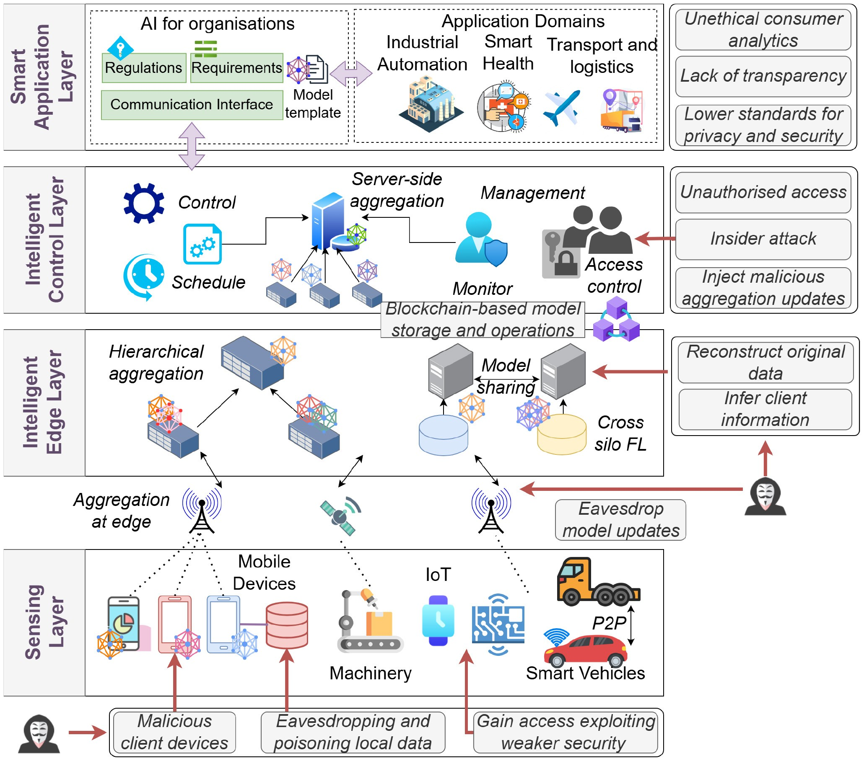
FIGURE 7. Overview of usage of FL over 6G vision layered architecture and potential privacy challenges.
among them. This layer focuses on regulations, requirements, and communication interfaces. It contains templates for AI models that adhere to the specific business requirements and regulations. At this level, some challenges are unethical consumer analytics with the misuse of consumer data for unethical analytics, lack of transparency with insufficient transparency in data processing and handling, and lower standards for privacy and security by implementing privacy and security standards that are below the optimal level.
Below the smart application layer, the Intelligent Control Layer handles server-side aggregation, model management, and monitoring using the blockchain for secure operations. This layer also includes access control to prevent unauthorized data access and insider attacks. In this layer, control and scheduling interact with server-side aggregation to manage the AI models. Access control ensures that only authorized personnel can access the data and models. It oversees the activities of the entire FL process. Blockchain-based model storage acts as a secure storage, and decentralized FL operations can also be performed using blockchain technology and are located between the intelligent control and edge layers. Potential security and privacy challenges at this level include unauthorized access to sensitive data, insider attacks initiated by authorized personnel within the organization, and the injection of malicious aggregation updates that introduce false updates into the aggregation process.
The Intelligent Edge Layer focuses on hierarchical and edge-level data aggregation, with mechanisms for model sharing across different silos while highlighting risks like eavesdropping and data reconstruction. Potential security and privacy challenges in this layer include eavesdrop model updates where unauthorized interception of model updates occur, reconstruction of original data where inferring or
TABLE 6. Privacy issues and its impact on B5G/6G architectural layers.
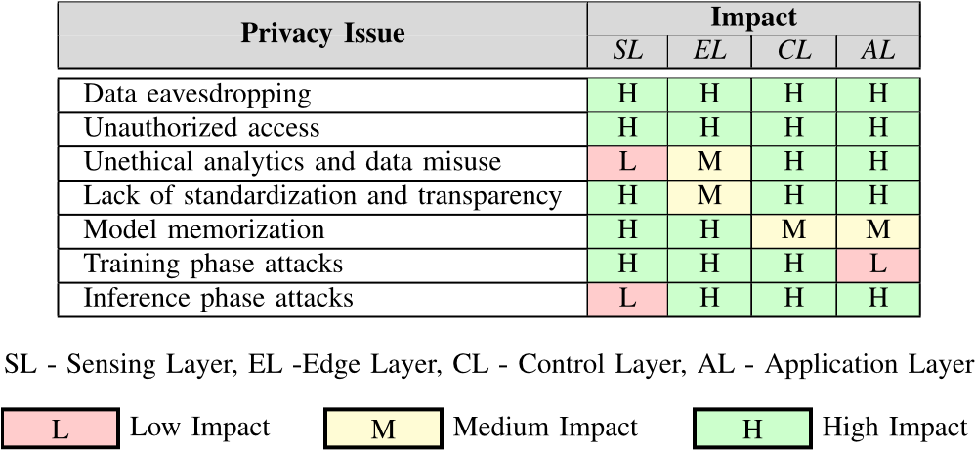
reconstruction of original data from aggregated information is enabled, and client information inference to determine sensitive client information through analysis.
At the base, the Sensing Layer includes mobile devices, IoT, and smart vehicles that collect and preliminarily aggregate data, facing challenges such as malicious devices, data poisoning, and security vulnerabilities. Potential security and privacy challenges at this level include malicious client devices that are at risk of intentionally corrupting data, eavesdropping, and poisoning local data through unauthorized access and malicious data manipulation, and exploiting weaker security measures to gain access to systems with weaker security measures. In terms of data flow and interactions, data flow begins in the sensing layer, where devices collect and possibly aggregate data. This data is then sent to the intelligent edge layer for further aggregation and initial sharing of models. The aggregated data and models are forwarded to the intelligent control layer for centralized control, scheduling, and monitoring. Finally, the smart application layer uses this data and models for various applications, adhering to regulations and requirements. Table 6 provides some key overlapping threats and attacks across multiple layers of 6G. This 6G architecture highlights the importance of securing each layer to protect the overall integrity and privacy of the FL process in a 6G network. Each layer interacts to ensure efficient data processing and AI model application while addressing specific security threats and maintaining privacy through measures such as blockchain storage and stringent access controls.
V. PRIVACY ENHANCING MECHANISMS FOR FL IN 6G Privacy-enhancing mechanisms refer to a broad class of technologies designed to safeguard various dimensions of privacy, including data confidentiality, user anonymity, and data integrity. Several privacy-preserving mechanisms have been proposed in the recent literature, e.g., [17], [41], [105], [172], [173], to enhance the resilience of FL against privacy attacks. These solutions mainly include DP, SMC, model masking and cryptographic techniques such as HE. They focus on different aspects of privacy, such as keeping data confidential, ensuring users remain anonymous, and making sure that the data being processed is accurate. For example, HE helps maintain data confidentiality by
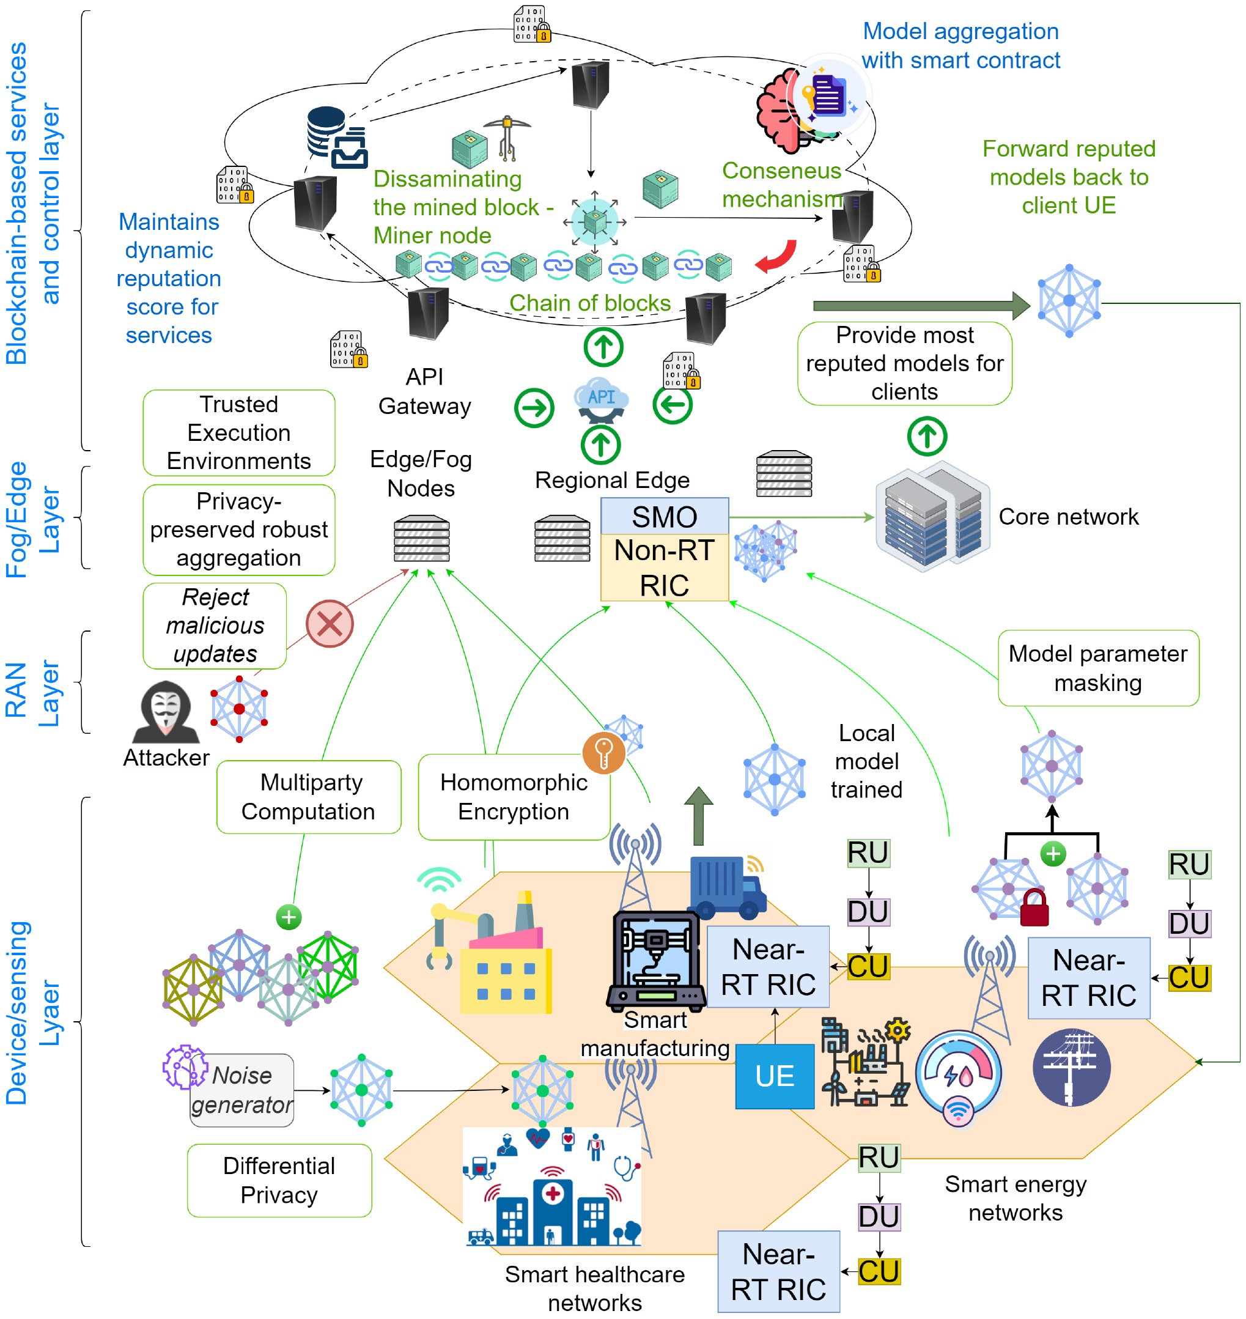
FIGURE 8. Possible privacy-enhancing solutions to mitigate privacy-related threats in FL.
allowing computations to be performed on encrypted data without ever revealing the original information. SMC keeps data confidential and ensures user anonymity, as it enables collaboration without exposing individual data inputs. DP focuses on protecting user identities by adding random noise to data, preventing personal details from being uncovered in aggregated results. Model masking further safeguards data by ensuring that sensitive information does not leak during machine learning model training.
Additionally, technologies such as Blockchain contribute to maintaining data integrity and security by offering a decentralized and tamper-resistant approach to storing data, which ensures that information remains intact and unaltered across a distributed network. These privacy-enhancing mechanisms are essential for addressing the unique challenges posed by the decentralized and data-heavy nature of 6G environments. Fig. 8 provides an overview of the potential privacy issues and their applicability over different layers in the 6G architecture. Next, we further discuss each of these solutions in detail.

A. DIFFERENTIAL PRIVACY
The notion of DP is based on giving plausible deniability to the participants, generally by adding random noise to their inputs [174]. FL can, therefore, apply DP-based techniques to guarantee privacy for its users, even if the model updates are captured by an adversary since the models trained via techniques like Differentially Private Stochastic Gradient Descent (DP-SGD) [175] can minimize the leakage of data through DP-based noise.
The (-δ) DP is formally defined through the following inequality [176]:
Pr[M(x) ∈ S] ≤ ePr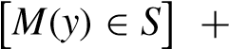δ, (1)
where the randomised algorithm M gives -DP if datasets x and y differing on at most one element ∀S ⊂ Range(M). The value is called the privacy budget, and δ is the probability of privacy leakage, which is a constant. However, the work in [177] shows that the model accuracy may get reduced with noise through DP. The authors in [178] apply Local Differential Privacy (LDP) to provide privacy guarantees for FL model parameter updates and a collaborative training approach for utility-aware perturbations to prevent uncontrolled noise. They also mention that the LDP mechanism can protect FL from inference attacks.
In the context of B5G/6G, DP can be applied at the device layer, where end users can introduce a controlled noise via DP-based aggregation. This step is relatively simple and has lesser computational complexity as noise is randomly generated and added to the model or data. Furthermore, no additional communication overhead can be expected as the structure and architecture of the model parameters will remain the same. It could support various user devices in future networks since the algorithms and noise bounds are well-defined and implemented as DP-based wrappers [179]. However, the issue of reduction of model accuracy comes as a significant trade-off for DP [180], [181], as it limits the utility of the FL models.

B. SECURE MULTI-PARTY COMPUTATION
SMC enhances privacy in FL by enabling multiple participants to jointly compute aggregated model updates without revealing individual data. It divides the model parameters into secret shares among participating devices [173]. Each device holds a share of the model and collaborates through secure protocols to perform computations on its share. These computations, such as addition and multiplication, are executed without disclosing the actual model parameters. Only the final aggregated result is obtained, ensuring individual contributions remain confidential throughout the process. B5G/6G services can adopt SMC so that malicious aggregators cannot isolate any targeted client. This helps mitigate several privacy-related issues in B5G/6G with FL, including privacy leakage via model memorization since the end server will only get the aggregated models. Thus, it will also mitigate the possibility of inference phase attacks and build trust among end users to contribute more to the FL-based services in B5G/6G. In FL, SMC can be efficiently implemented using a technique such as secret sharing, such as Shamir’s Secret Sharing scheme [182], [183]. In this setup, each participant splits their secret (e.g., model update or gradient) into multiple shares. Let s_{i} represent the secret from participant i, and let N denote the total number of participants. Each secret is divided into N shares, where a share for the client j can
j
be presented as S_{i}. Hence, the original secret is the total of s = Si1 + Si2 + ··· + SiN.
In FL, when each participant has received their shares, they send them to a trusted aggregator or a subset of devices, which securely sums the shares to reconstruct the global model update. The total sum of all secrets s_{i} is calculated by summing the shares from all clients as:
N N
S 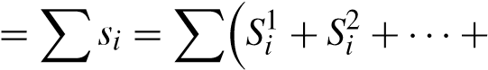 S_{i}^{N} (2)
i=1 i=1
Therefore, the final result S is the aggregated value of all participants’ contributions, and privacy is preserved, as no individual can learn another participant’s full secret. This method enables privacy-preserving aggregation in FL over 6G networks, as 6G provides the required communication capacity to split the shares and establish rapid communication.
SMC can also be combined with other approaches like DP. Authors in [184] use a hybrid approach of using both SMC and DP, where they attempt to reduce the utility loss from DP by providing lower noise quantity through SMC. Importantly, SMC ensures that privacy protection doesn’t compromise model utility [185], as the final aggregated model can remain accurate. Therefore, SMC is a powerful technique that effectively safeguards privacy in 6G by enabling collaborative model training without exposing sensitive data. However, it also comes with tradeoffs, including heightened communication overhead [185], which should be carefully considered in designing privacy-conscious FL systems.

C. MODEL MASKING
Another approach for preserving privacy in FL model updates is by using a mask on top of the original model update, which gets canceled upon aggregation. For example, work in [186] uses a self-canceling zero-mean uniform noise mask on the model parameters during client model training, which gets canceled over local epochs. This helps mitigate privacy leakage if an adversary accesses the local models during the training phase. Further, the noise is added during model transmission, where individual clients’ noise additions will be mitigated over many client contributions. Work presented in [187] provides a dual-masking framework to prevent model inversion and model poisoning attacks by partially updating model weights with masks for two layers. Additive pairwise masking is another approach where two trustworthy clients agree on a random mask, which gets canceled out when aggregated at the server [188]. This makes any malicious or curious server unable to learn about the individual clients. Since the computation overhead for calculating masks is relatively low, B5G services could utilize this technique in applications where lightweight computations are possible, such as IoT edge and resourceconstrained user devices. However, if the mask is known by the attacker, the model will be recoverable. Thus, it should be kept private and secure.

D. HOMOMORPHIC ENCRYPTION
HE offers a compelling application within the context of FL for the evolution into B5G/6G networks. Allowing computable functions on encrypted data enables secure model aggregation without exposing the model parameters [189]. This approach ensures robust privacy guarantees while maintaining model utility. In HE, each client encrypts their local model update before sending it to the central server, ensuring that their raw data is never exposed. Let s_{i} represent the secret, such as the model update or gradient from client i, and let N be the total number of clients. Suppose the encryption operation from the client i is Enc(s_{i}). HE allows the server to perform aggregation without decryption as:
Enc(S) = Enc(s₁) + Enc(s₂) + ··· + Enc(S_{N}) (3)
Here, the aggregator cannot learn the individual model updates. It can only decrypt the encrypted version of the global model S via a decryption function as S = Dec(Enc(s)). Therefore, it makes the individual updates confidential.
The work in [190] proposes a framework for FL using a partially HE scheme and shows that accuracy deviation with the mechanism is less than 1%. Despite these benefits, this technique comes with trade-offs. The authors show that increasing key lengths also increases the time taken for aggregation. Thus, the computational cost and complexity associated with HE can be significant [190], [191], especially for resource-constrained IoT devices in the dynamic and data-intensive environments of B5G/6G networks. Furthermore, HE prevents any inspection of client models, thus, requiring all the clients to be trustworthy. Therefore, they may be of limited use when there are untrustworthy clients performing model poisoning [192]. However, in cases where FL is done at higher layers in the B5G/6G architecture, where the parties involved are resourceful (e.g., cross-silo FL among multiple organizations), this approach can provide strong protection against privacy leakages.

E. BLOCKCHAIN-BASED MECHANISM IN FL
Blockchain can be incorporated in developing privacypreserved model sharing [193] through a tamper-proof ledger to improve transparency. FL architectures such as P2P FL can incorporate blockchain with techniques such as SMC to make scalable and fault-tolerant defenses against attacks through consensus mechanisms [193], [194]. It can also provide incentive mechanisms for honest clients for their trustworthiness and encourage them to high-quality model updates [71]. However, issues such as latency [195] and computational costs [196] for mining and validation are seen as trade-offs when integrating blockchain.
When considering privacy-preserving FL for IoT and edge computing with blockchain, work in [71] focuses on blockchain-based privacy-preserving FL for IoT devices ensuring secure model updates. Authors in [88] introduce a decentralized privacy-preserving framework using blockchain and FL in fog computing, while [197] proposes a privacy-preserving framework using FL and blockchain for IoT healthcare data. Additionally, [198] discusses integrating FL and blockchain for privacy protection in IoT, [199] proposes a multi-layered security FL platform for IoT using blockchain, [200] focuses on blockchain-enabled FL for privacy-preserving deep learning in industrial IoT systems and [201] discusses the use of blockchain and FL in healthcare IoT systems for privacy and fraud prevention. For privacy-preserving FL in vehicular networks using blockchain, [202] proposes a blockchain-based FL scheme for privacy in the Internet of Vehicles (IoV), [203] proposes a blockchain solution for privacy-preserving FL in IoV, ensuring secure updates. Reference [204] provides a comprehensive survey on blockchain and FL integration in vehicular IoT networks, [205] discusses a blockchain-based privacypreserving FL system for detecting cyber threats in intelligent transportation systems and [206] proposes “ShareChain,” a blockchain-enabled model for secure patient data sharing using FL in healthcare.
For blockchain-enabled privacy-preserving FL in healthcare, authors in [207] focuses on blockchain-enabled FL for privacy in healthcare systems. For privacy-preserving and verifiable FL using blockchain, authors in [208] present a blockchain-based, privacy-preserving, and verifiable FL method, a verifiable blockchain-based FL approach is proposed in [209], ensuring secure model updates. Authors in [210] introduce a Byzantine-robust, privacy-preserving FL system using blockchain, and the paper in [211] discusses a blockchain-based reputation-aware FL system for enhancing trust. For blockchain-enabled FL with decentralized learning, the paper in [212] proposes a blockchain-based FL model for privacy-preserving traffic flow prediction, authors in [213] integrate blockchain and FL for privacypreserving mobile crowdsensing, the paper in [214] presents a blockchain-enabled FL design for privacy preservation in decentralized environments, authors in [215] introduce a privacy-preserving blockchain-enabled FL model for B5Gdriven edge computing, the paper in [216] proposes a privacy-preserving blockchain-based FL system for largescale decentralized machine learning and the paper in [217] proposes “Artificial Identification,” a novel privacy framework for FL based on blockchain. Finally, opportunities and challenges in FL and blockchain integration are highlighted in [38] to explore the overlap of FL and blockchain in edge computing and discuss challenges and opportunities.

F. OTHER POSSIBLE PRIVACY ENHANCING SOLUTIONS
Other notable mechanisms for FL include solutions such as:
- Federated knowledge distillation - transferring knowledge from a fully trained model to an alternative model [218]. This can prevent the sharing of original model parameters; instead, knowledge is shared through the alternative model [41]. However, the reduction in efficacy or the loss of knowledge is a problem to be addressed, and designing effective transfer models is another challenging concern [219].

VI. PRIVACY PRESERVATION AT DIFFERENT 6G LAYERS
When equipped with proper privacy-enhancing mechanisms, FL can be a powerful distributed PPML for future networks. The following subsections discuss privacy benefits when using FL for B5G/6G-related applications and services at each 6G vision architecture layer.
A. PRIVACY PRESERVATION AT THE B5G/6G DEVICES FL can provide a significant advantage for local client devices for maintaining the privacy of private and sensitive data, giving users more control. FL can also be used over many end-user devices, mobile phones, wearables, sensor equipment, and IIoT-based equipment, which provides more possibility for addressing privacy issues for a wide range of user bases across numerous applications that require ML. It promotes data localization, where massive data generated from B5G/6G devices will remain at the individual devices. In many jurisdictions, data protection regulations are becoming more stringent for end devices such as IoT [234]. FL can help organizations comply with these regulations by minimizing the need to collect, store, and transmit sensitive data from the devices they provide the service to. It inherently reduces raw data sharing, thus reducing the overhead of computationally expensive encryption techniques. However, as the device layer can be considered highly vulnerable to attacks, it is important to implement privacy-enhancing techniques at the devices. Local DP [235] added at the device level can further increase the privacy of local models shared by the clients. Furthermore, lightweight encryption techniques [236] and increased security measures at userlevel access can be employed to minimize the risks of privacy leakages.

B. OVER THE AIR FL FOR NETWORK PRIVACY
TABLE 9. Performance trade-offs of privacy enhancement mechanisms and possible solutions
 | 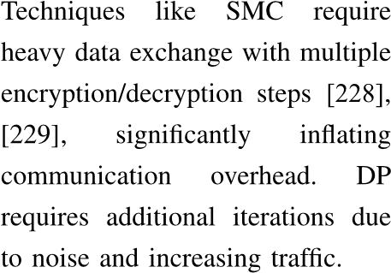 |  |  |  |  |  |  | 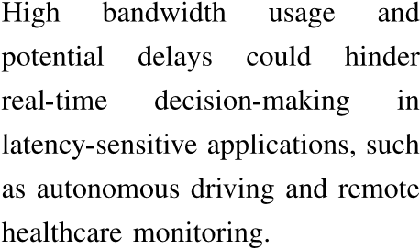 | 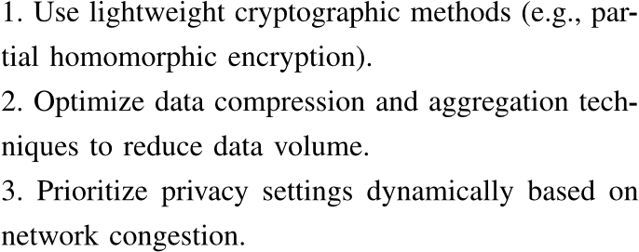
 | 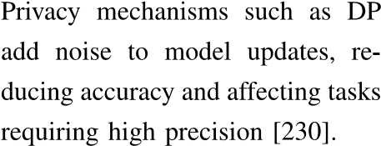 |  |  |  |  |  |  | 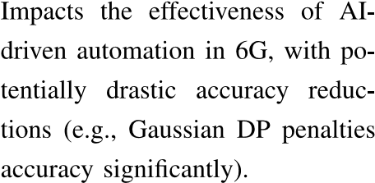 | 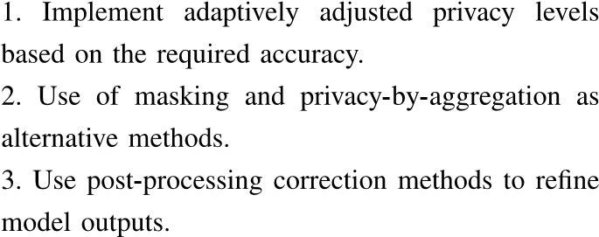
 |  |  |  |  | 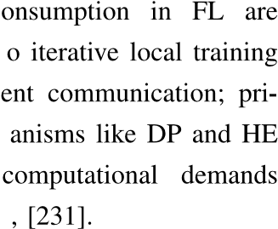 |  |  | 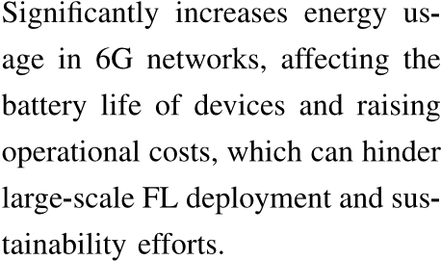 | 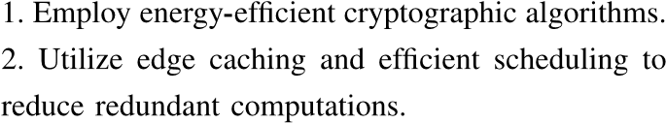
 | 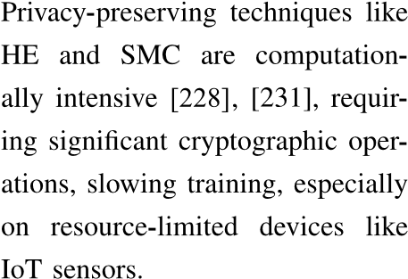 |  |  |  |  |  |  | 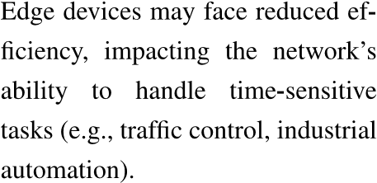 | 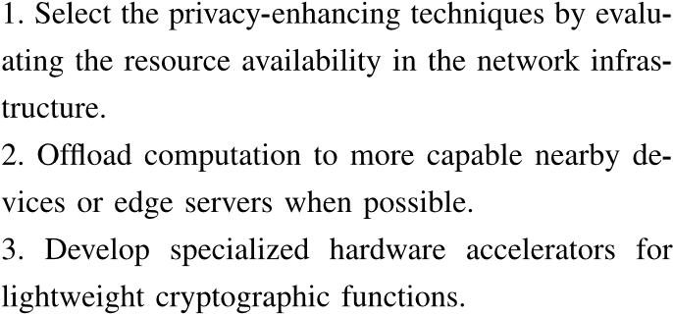
 | 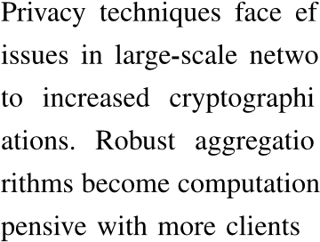 |  |  |  |  |  |  |  | 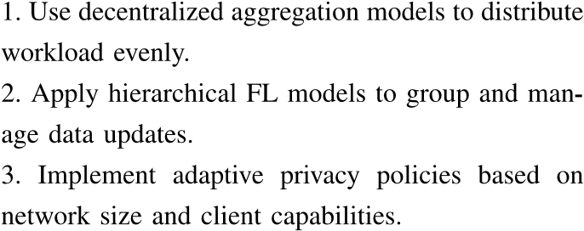
 | 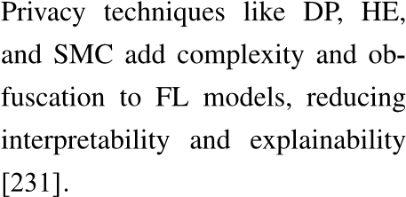 |  |  |  |  |  |  | 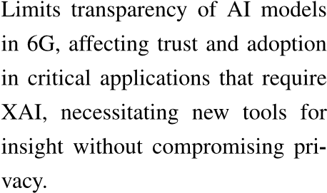 | 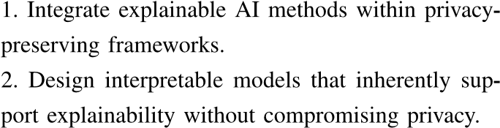
 | 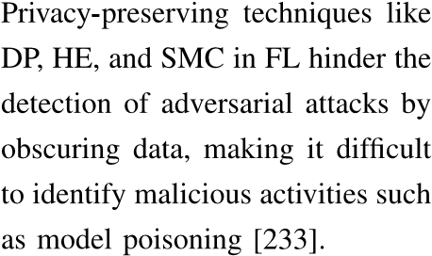 |  |  |  |  |  |  | 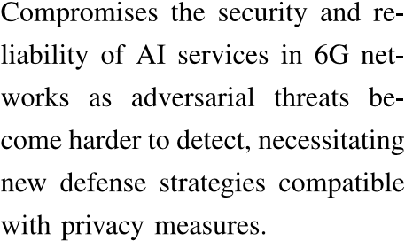 | 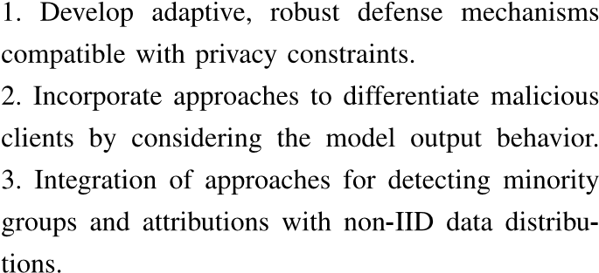

OTA FL performs aggregation by signal superposition of wireless multiple-access channels [227]. The work in [237] presents an OTA FL with anonymized devices for transmission. Here, the devices can simultaneously and efficiently transmit the uncoded model updates using the available spectrum. Here, uncoded refers to the transmission of models without considering error-correction codes in case of noise disruptions in the channel. In the uncoded transmission of FL implementation, the induced channel noise added to the original updates can be used directly as an advantage by considering it as a free privacy-inducing mechanism [238].
To measure the noise level in a differentially private manner, the authors in [238] use signal-to-noise ratio (SNR) to maintain an acceptable level of learning performance. We will further discuss differential privacy in Section V. Adding quantifiable noise naturally through this mechanism can reduce any extra computation costs for manually applying noise via differential privacy algorithms. Therefore, OTA FL
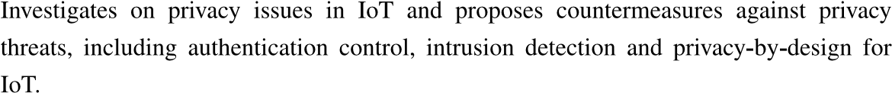
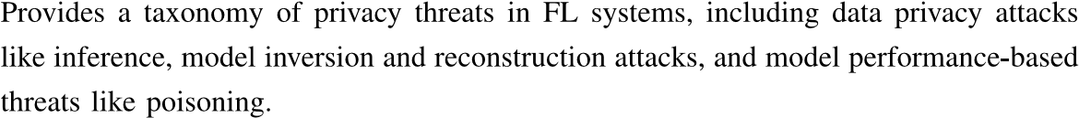
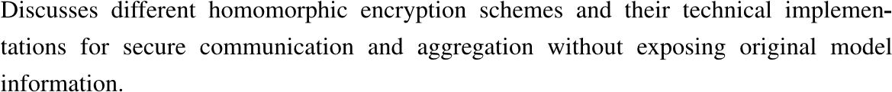
TABLE 10. Summary of related work for privacy of FL and its applicability on 6G
can be considered an attractive privacy-preserving strategy for wireless 6G networks when aggregating FL models over the network.

C. PRIVACY PRESERVATION AT THE B5G/6G EDGE AI
Limiting data exposure [239], [240] to external parties is a possible way of mitigating unintentional privacy leakages. One of the strategies to implement this in 6G is by bringing AI closer to the IoT edge [241], [242], where data and decisions are shared within the closer proximity of the data owners or the end users. This can be referred to as edge AI [243], [244]. With this approach, it will be easier to manage data privacy since they will be shared within a limited scope. Future B5G/6G networks are expected to include edge AI as a key enabler for greatly improved QoS and low latency communication [245], [246]. However, if centralized client-server-based ML is considered to train edge AI models, data from IoT sensors and user devices may still be transmitted to the edge server, which can lead to privacy leakages. Therefore, the question of achieving ML model training while keeping data private needs to be answered.
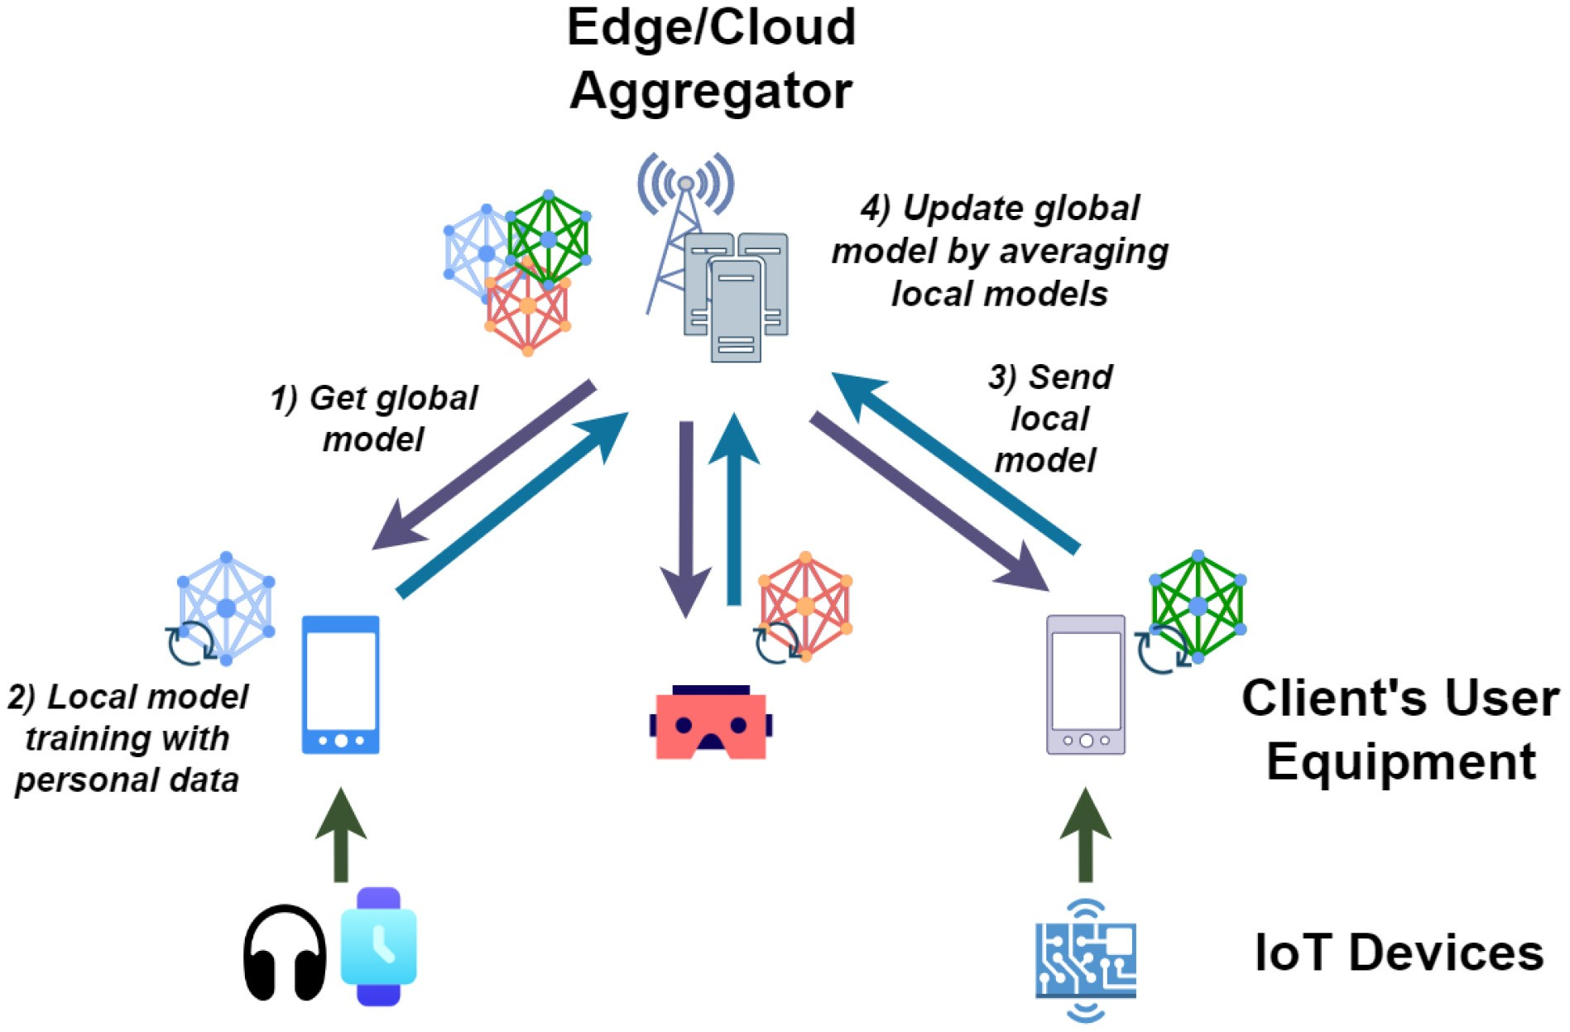
FIGURE 10. Aggregator and client-based FL system with IoT.
To address this question, FL is emerging as a PPML solution [7], which can be implemented at the edge. It aims to provide high-quality ML models while maintaining data privacy. Since data used in FL does not need to be moved from its original source, and the ML models are trained locally near the data source and aggregated remotely to create a global model, data privacy is protected with safety within the user premises. Thus, multiple IoT devices can act as workers to communicate with the edge server aggregator without sharing actual datasets [38]. Many recent works show the feasibility of FL to be implemented at the IoT edge as a privacy-preserved edge AI technique [46], [73], [247], [248]. A typical FL system with IoT clients at the edge and an aggregator is shown in Fig. 10.
Here, the aggregator can be either an edge or a remote cloud server. It can also have hierarchical model updates, where models will be aggregated at multiple levels of edge and cloud [85]. FL is designed to protect the privacy of individuals who contribute to the training process. Thus, 6G can utilize this distributed ML technique at the edge of AI to fulfill the requirements of ML-associated service functionalities while preserving privacy.

D. ENHANCING PRIVACY WITH FL-DRIVEN INTELLIGENT NETWORK MANAGEMENT AND ORCHESTRATION
The privacy of AI-driven network management tasks can be enhanced using FL. When managing multiple services, it may be necessary to make automated decisions based on the properties of services. Exposing them directly to the management layer can create a risk of leaking sensitive and private business data from these services since these management and control components can get compromised, be honest but curious, or malicious. This can create a lack of trust among service providers in the upper layer to share such information directly. In such cases, FL can be provided as a solution by facilitating distributed model training without sharing private data. For example, the work in [59] uses FL for predicting network slice performances where models trained on serviceoriented privacy-sensitive Key Performance Indicator (KPI) are shared by slice managers without directly exposing KPIs to the slice orchestrator. Another requirement in achieving zero-touch network management is to automate the detection of any malicious entities in the networks. For this, ML models that can detect anomalies in network traffic may be required; however, they could contain sensitive information if the individuals or devices who consume these services can be traced. Therefore, FL can provide an alternative approach by allowing privacy-preserved local training of such detection and defense models based on individual data [99], [249].

E. PRESERVING PRIVACY FOR 6G ASSOCIATED SERVICE APPLICATIONS WITH FL
Many applications serving as B5G/6G-based services can use FL to manage their internal data and collaborate among multiple services. For example, vertical FL can facilitate joint training of ML models based on data with fewer overlapping features. This may resemble a scenario where multiple services are provided by different applications for the same consumer base. It could be beneficial for applications like Metaverse, where numerous services should collaborate at high speeds to maintain better QoS and provide a seamless experience to users. FL done by a distinct set of clients is also termed as cross-silo FL [250]. One feature that could arise in cross-silo FL is the relatively small number of collaborators compared with cross-device FL, which can be millions of devices. Therefore, proper privacy mechanisms are an essential requirement for the models that organizations contribute to the FL process. Another key issue emerging here is the central server, where no party involved in sharing the models can no longer trust the other collaborators unless the services are provided by the same organization. In such cases, many approaches are available that perform decentralized aggregations, and blockchain is often used for transparency and decentralized control. Examples include the work in [251], which employs an FL framework for multiple organizations with decentralized aggregation and blockchain for verification and reward based on the quality of model updates.

VII. FEDERATED LEARNING PRIVACY IMPLEMENTATION IN 6G USE CASES
Integrating FL Privacy mechanisms such as DP, HE, and SMC techniques in 6G networks addresses key privacy challenges. This section outlines three specific use cases demonstrating how these technologies can be applied in 6G networks.

A. FEDERATED LEARNING FOR REAL-TIME CROWD SENSING IN 6G-ENABLED ULTRA-DENSE ENVIRONMENTS
In ultra-dense environments, 6G’s high bandwidth and low latency support FL for real-time crowd sensing [252]. Devices train models locally on sensed data, sending only encrypted model updates to an edge server, avoiding raw data sharing. This distributed learning approach reduces the
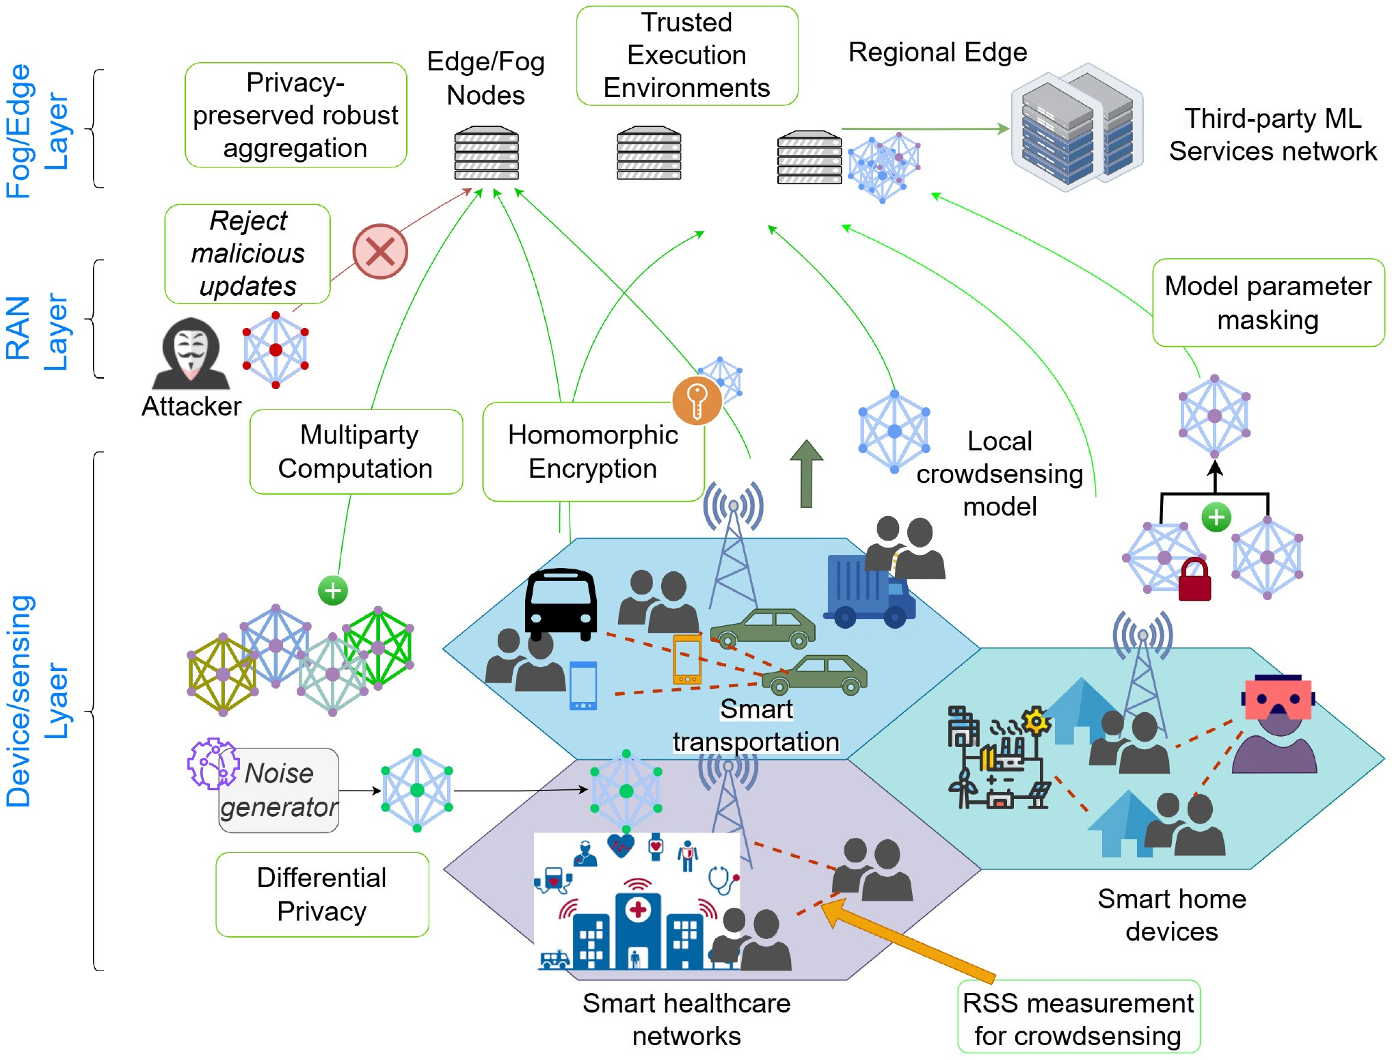
FIGURE 11. Crowdsensing among multiple domains and securely sharing the FL models.
risk of privacy breaches and minimizes the network load, as raw data transfer is replaced by periodic model updates. The edge servers can aggregate these updates from numerous devices, building a global model that reflects crowd insights without compromising individual privacy [253]. Scenarios like crowd density estimation, environmental monitoring, or public safety alerts can be developed via this FL-enabled approach.
Figure 11 provides an overview of the mobile crowdsensing-based FL in a 6G network. Multiple domains with highly dense networking environments like urban smart vehicle traffic, public offices or private home complexes can utilize FL to collect signal data like Received Signal Strength (RSS) locally and train FL models without exposing exact information about the signal sources. Moreover, DP can be applied to device model updates, adding noise to prevent reidentification. HE secures model updates in transit, enabling aggregation without decryption and ensuring robust crowd analytics and privacy.

1) IMPLEMENTATION CHALLENGES
Implementing FL with added privacy-enhancing mechanisms like DP and HE in a real-time crowd-sensing environment presents several challenges. Due to the limited processing power of many user devices, especially smartphones, applying DP and HE may significantly increase computational demands and latency, potentially impacting the real-time responsiveness required for crowd management. HE’s intensive computations can slow down edge-device interactions, particularly in ultra-dense settings where many devices simultaneously transmit model updates, increasing congestion at the edge server. Additionally, the noise introduced by DP can reduce the accuracy of crowd predictions, making it difficult to achieve high-quality insights. Maintaining synchronized encryption standards across devices complicates seamless data aggregation at the edge. Moreover, the differences in hardware and mobile devices in such
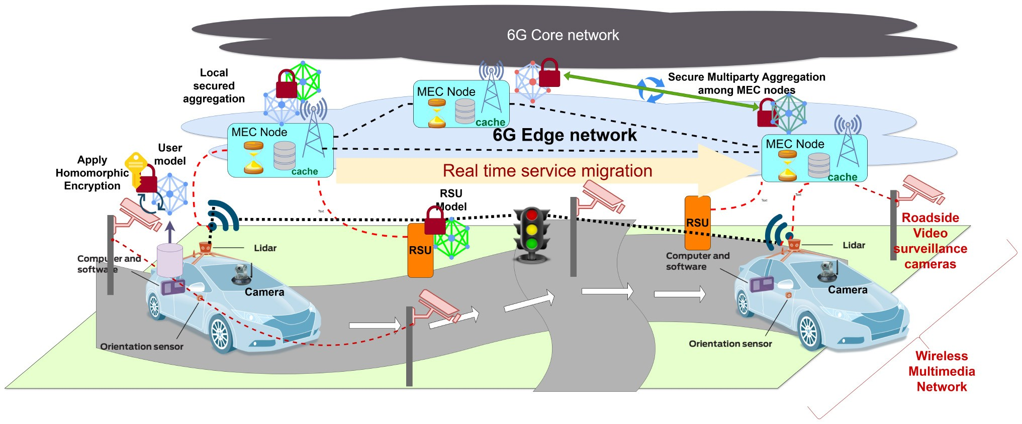
FIGURE 12. FL-based secure and private model sharing of vehicles and RSUs with MEC.
diverse environments can make it further difficult to enable a unified approach of encryption standards and processing capabilities, which further complicates data aggregation, limiting the scalability and responsiveness in real environments.

2) STRATEGIES TO ADDRESS CHALLENGES
To address these challenges, optimized encryption protocols specifically designed for mobile devices can be employed to reduce processing load. Offloading some computations to nearby 6G-enabled edge nodes can help mitigate latency, as these nodes can handle more intensive data processing. Adaptive privacy mechanisms could also be implemented, adjusting the level of DP noise based on crowd density and ensuring the right balance between data accuracy and privacy. Utilizing specialized hardware, like mobile-optimized encryption accelerators, could also help in processing encrypted updates faster.

B. FEDERATED LEARNING FOR 6G-ENABLED REAL-TIME AUTONOMOUS VEHICLE AND TRAFFIC MANAGEMENT
The ultra-low latency of 6G networks enables real-time management of autonomous vehicles and traffic systems using FL to create adaptive AI models [252]. In this scenario, autonomous vehicles, roadside units (RSUs), and mobile edge computing (MEC) nodes collaborate to train local models on traffic and sensor data [254], sending only encrypted model updates to a central model without transferring raw data. This decentralized learning process allows for real-time traffic predictions and collision avoidance strategies while ensuring data privacy.
As shown in Fig. 12, MEC nodes and RSUs support Federated Learning by aggregating model updates from autonomous vehicles and other roadside sensors, such as LiDAR and video surveillance cameras. These updates are encrypted using HE, allowing MEC nodes to aggregate data without accessing unencrypted information. SMC ensures that model updates from different sources (e.g., vehicles and RSUs) are aggregated privately, maintaining the confidentiality of each data source. This collaborative approach in 6G networks allows for efficient, privacy-preserving real-time traffic and vehicle management.

1) IMPLEMENTATION CHALLENGES
Implementing FL with HE and SMC in autonomous vehicle and traffic management raises significant challenges, primarily due to the ultra-low latency requirements essential for safety-critical applications. The computational overhead of HE can delay data processing, especially on devices with limited resources like RSUs. Additionally, SMC requires secure and synchronized data communication between multiple parties, which can be challenging in high-speed, mobile environments with fluctuating network quality. Ensuring data integrity and security during transmission over open network channels adds another layer of complexity.

2) STRATEGIES TO ADDRESS CHALLENGES
To mitigate these challenges, leveraging the dedicated infrastructure of 6G networks, such as MEC nodes located near RSUs and autonomous vehicles, can reduce latency by offloading complex computations to powerful edge nodes. Hardware accelerators, including GPUs and specialized encryption chips in MEC nodes, can enhance the processing speed of HE and SMC. Implementing adaptive encryption, where only essential or sensitive data is fully encrypted, may also balance processing load and data security. Continuous synchronization protocols across 6G-connected devices will ensure the secure and efficient aggregation of model updates in real-time.
C. FEDERATED LEARNING FOR INTELLIGENT TRAFFIC

MANAGEMENT IN 6G-ENABLED OPEN RADIO ACCESS NETWORKS
Open Radio Access Networks (ORAN) leverage the flexibility of 6G to support scalable and efficient network management. In this scenario, FL is used to develop intelligent traffic management models across distributed ORAN nodes. Each ORAN node, such as base stations and edge computing units, trains a local model on network traffic data, adjusting parameters for load balancing, congestion control, and resource allocation. These local models then send encrypted updates to a central controller for aggregation, enabling a global model without needing access to raw data from individual ORAN nodes.
As shown in Fig. 13, MEC nodes within ORAN collect and aggregate model updates using privacy-preserving methods. HE can be applied to these updates, allowing the MEC nodes to perform computations on encrypted data without decrypting it. SMC further enhances privacy by ensuring that updates from various ORAN nodes can be aggregated securely, preventing any single entity from gaining full access to the underlying data. This approach enables the development of adaptive, real-time traffic management models that respect user privacy and network security.

1) IMPLEMENTATION CHALLENGES
Implementing FL in ORAN with HE and SMC faces several challenges, primarily due to the need for ultra-low
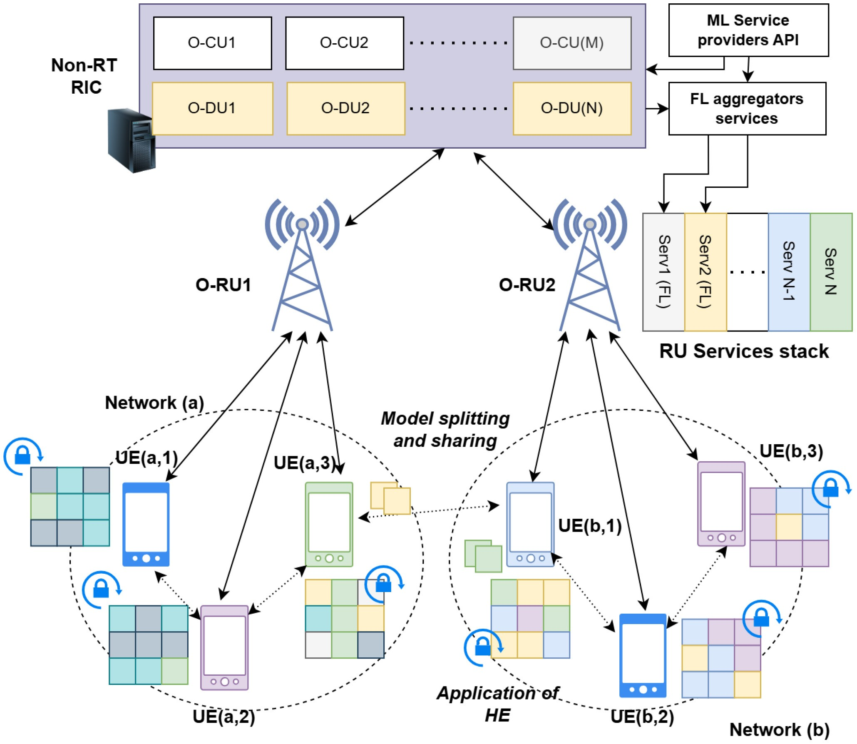
FIGURE 13. ORAN-based FL services and model aggregation over the network.
latency in handling real-time traffic data. HE is computationally intensive, which can delay traffic management responses if not optimized for edge devices. Additionally, maintaining synchronization across multiple ORAN nodes that operate independently in diverse geographic locations can be difficult. Furthermore, SMC requires reliable and secure communication channels, which can be challenging in ORAN environments with potentially fluctuating connectivity.

2) STRATEGIES TO ADDRESS CHALLENGES
To address these challenges, using hardware accelerators like GPUs and FPGAs in MEC nodes can speed up HE operations, ensuring that data remains encrypted without compromising processing time. Hybrid encryption schemes, where only high-priority data is fully encrypted, can also reduce computational load. For synchronization, adaptive aggregation protocols across ORAN nodes can help maintain model consistency and allow for seamless integration of model updates. Establishing robust, high-speed communication links in the 6G infrastructure further supports the secure and timely aggregation of data, ensuring that ORAN-based traffic management models remain responsive and effective.

REFERENCES
- R. Chataut, M. Nankya, and R. Akl, “6G networks and the AI revolution—Exploring technologies, applications, and emerging challenges,” Sensors, vol. 24, no. 6, p. 1888, 2024.
- P. Kairouz et al., “Advances and open problems in federated learning,” Found. Trends Mach. Learn., vol. 14, nos. 1–2, pp. 1–210, 2021.
- M. Alazab, R. M. S. Priya, M. Parimala, P. K. R. Maddikunta, T. R. Gadekallu, and Q.-V. Pham, “Federated learning for cybersecurity: Concepts, challenges, and future directions,” IEEE Trans. Ind. Informat., vol. 18, no. 5, pp. 3501–3509, May 2022.
- The Next G Alliance. “6G roadmap for vertical industries.”
2023. [Online]. Available: https://nextgalliance.org/white_papers/6groadmap-vertical-industries/
- Q. Yang, Y. Liu, T. Chen, and Y. Tong, “Federated machine learning: Concept and applications,” ACM Trans. Intell. Syst. Technol., vol. 10, no. 2, pp. 1–19, 2019.
- T. Li, A. K. Sahu, A. Talwalkar, and V. Smith, “Federated learning: Challenges, methods, and future directions,” IEEE Signal Process. Mag., vol. 37, no. 3, pp. 50–60, May 2020.
- B. McMahan, E. Moore, D. Ramage, S. Hampson, and B. A. Y. Arcas, “Communication-efficient learning of deep networks from decentralized data,” in Proc. Artif. Intell. Stat., 2017, pp. 1273–1282.
- C. Xu and G. Neglia, “What else is leaked when eavesdropping federated learning?” in Proc. CCS Workshop Privacy Preserving Mach. Learn. (PPML), 2021, p. 12.
- B. Ghimire and D. B. Rawat, “Recent advances on federated learning for cybersecurity and cybersecurity for federated learning for Internet of Things,” IEEE Internet Things J., vol. 9, no. 11, pp. 8229–8249, Jun. 2022.
- J. Passerat-Palmbach et al., “Blockchain-orchestrated machine learning for privacy preserving federated learning in electronic health data,” in Proc. IEEE Int. Conf. Blockchain (Blockchain), 2020, pp. 550–555.
- M. Y. Topaloglu, E. M. Morrell, S. Rajendran, and U. Topaloglu, “In the pursuit of privacy: The promises and predicaments of federated learning in healthcare,” Front. Artif. Intell., vol. 4, Oct. 2021, Art. no. 746497.
- O. Marfoq, G. Neglia, R. Vidal, and L. Kameni, “Personalized federated learning through local memorization,” in Proc. Int. Conf. Mach. Learn., 2022, pp. 15070–15092.
- P. Liu, X. Xu, and W. Wang, “Threats, attacks and defenses to federated learning: issues, taxonomy and perspectives,” Cybersecurity, vol. 5, no. 1, p. 4, 2022.
- X. Luo, Y. Wu, X. Xiao, and B. C. Ooi, “Feature inference attack on model predictions in vertical federated learning,” in Proc. IEEE 37th Int. Conf. Data Eng. (ICDE), 2021, pp. 181–192.
- A. E. Ouadrhiri and A. Abdelhadi, “Differential privacy for deep and federated learning: A survey,” IEEE Access, vol. 10, pp. 22359– 22380, 2022.
- C. Zhang, S. Li, J. Xia, W. Wang, F. Yan, and Y. Liu, “BatchCrypt: Efficient homomorphic encryption for cross-silo federated learning,” in Proc. USENIX Annu. Techn. Conf. (USENIX ATC), 2020, pp. 493–506.
- Y. Li, Y. Zhou, A. Jolfaei, D. Yu, G. Xu, and X. Zheng, “Privacypreserving federated learning framework based on chained secure multiparty computing,” IEEE Internet Things J., vol. 8, no. 8, pp. 6178–6186, Apr. 2021.
- S. K. Lo et al., “Toward trustworthy Ai: Blockchain-based architecture design for accountability and fairness of federated learning systems,” IEEE Internet Things J., vol. 10, no. 4, pp. 3276–3284, Feb. 2023.
- Z. Yang, M. Chen, K.-K. Wong, H. V. Poor, and S. Cui, “Federated learning for 6G: Applications, challenges, and opportunities,” Engineering, vol. 8, pp. 33–41, Jan. 2022.
- P. Porambage, G. Gür, D. P. M. Osorio, M. Liyanage, A. Gurtov, and M. Ylianttila, “The roadmap to 6G security and privacy,” IEEE Open J. Commun. Soc., vol. 2, pp. 1094–1122, 2021.
- D. Sirohi, N. Kumar, P. S. Rana, S. Tanwar, R. Iqbal, and M. Hijjii, “Federated learning for 6G-enabled secure communication systems: A comprehensive survey,” Artif. Intell. Rev., vol. 56, pp. 11297– 11389, Mar. 2023.
- S. H. A. Kazmi, F. Qamar, R. Hassan, K. Nisar, and M. A. Al-Betar, “Security of federated learning in 6G era: A review on conceptual techniques and software platforms used for research and analysis,” Comput. Netw., vol. 245, May 2024, Art. no. 110358.
- O. Nassef, W. Sun, H. Purmehdi, M. Tatipamula, and T. Mahmoodi, “A survey: Distributed machine learning for 5G and beyond,” Comput. Netw., vol. 207, 2022, Art. no. 108820.
- M. Al-Quraan et al., “Edge-native intelligence for 6G communications driven by federated learning: A survey of trends and challenges,” IEEE Trans. Emerg. Topics Comput. Intell., vol. 7, no. 3, pp. 957–979, Jun. 2023.
- W. Xu, Z. Yang, D. W. K. Ng, M. Levorato, Y. C. Eldar, and
M. Debbah, “Edge learning for B5G networks with distributed signal processing: Semantic communication, edge computing, and wireless sensing,” IEEE J. Sel. Topics Signal Process., vol. 17, no. 1, pp. 9–39, Jan. 2023.
- D. Javeed, M. S. Saeed, I. Ahmad, M. Adil, P. Kumar, and A. N. Islam, “Quantum-empowered federated learning and 6G wireless networks for IoT security: Concept, challenges and future directions,” Future Gener. Comput. Syst., vol. 160, pp. 577–597, Nov. 2024.
- M. A. Ferrag et al., “Edge learning for 6G-enabled Internet of Things: A comprehensive survey of vulnerabilities, datasets, and defenses,” 2023, arXiv:2306.10309.
- Q. Duan, J. Huang, S. Hu, R. Deng, Z. Lu, and S. Yu, “Combining federated learning and edge computing toward ubiquitous intelligence in 6G network: Challenges, recent advances, and future directions,” IEEE Commun. Surveys Tuts., vol. 25, no. 4, pp. 2892–2950, 4th Quart., 2023.
- X. Yin, Y. Zhu, and J. Hu, “A comprehensive survey of privacypreserving federated learning: A taxonomy, review, and future directions,” ACM Comput. Surveys, vol. 54, no. 6, pp. 1–36, 2021.
- A. Imteaj, U. Thakker, S. Wang, J. Li, and M. H. Amini, “A survey on federated learning for resource-constrained IoT devices,” IEEE Internet Things J., vol. 9, no. 1, pp. 1–24, Jan. 2022.
- C. Easttom, “Quantum computing and cryptography,” in Modern Cryptography: Applied Mathematics for Encryption and Information Security. Cham, Switzerland: Springer, 2022, pp. 397–407.
- R. R. Harmon and N. Auseklis, “Sustainable it services: Assessing the impact of green computing practices,” in Proc. IEEE Int. Conf. Manag. Eng. Technol. (PICMET), 2009, pp. 1707–1717.
- Q. Zeng, Y. Du, K. Huang, and K. K. Leung, “Energy-efficient radio resource allocation for federated edge learning,” in Proc. IEEE Int. Conf. Commun. Workshops (ICC Workshops), 2020, pp. 1–6.
- S. Wang et al., “Adaptive federated learning in resource constrained edge computing systems,” IEEE J. Sel. Areas Commun., vol. 37, no. 6, pp. 1205–1221, Jun. 2019.
- T. T. Huong et al., “Federated learning-based explainable anomaly detection for industrial control systems,” IEEE Access, vol. 10, pp. 53854–53872, 2022.
- A. Manna, H. Kasyap, and S. Tripathy, “MOAT: Model agnostic defense against targeted poisoning attacks in federated learning,” in Proc. 23rd Int. Conf. Inf. Commun. Security (ICICS), 2021, pp. 38–55.
- X. Zhao, W. Zhang, X. Xiao, and B. Lim, “Exploiting explanations for model inversion attacks,” in Proc. IEEE/CVF Int. Conf. Comput. Vis., 2021, pp. 682–692.
- A. Kuppa and N.-A. Le-Khac, “Adversarial XAI methods in cybersecurity,” IEEE Trans. Inf. Forensics Security, vol. 16, pp. 4924–4938, 2021.
- J. L. C. Bárcena et al., “Fed-XAI: Federated learning of explainable artificial intelligence models,” in Proc. 3rd Italian Workshop Explain. Artif. Intell. (XAI.it), 2022, pp. 104–117.

CHAMARA SANDEEPA (Student Member, IEEE) received the bachelor’s degree in electrical and information engineering from the University of Ruhuna, Sri Lanka, in 2020. He is currently pursuing the Ph.D. degree with the School of Computer Science, University College Dublin, Ireland. He is also a member of the Network Softwarization and Security Labs, UCD, a Contributing Researcher in the EU ROBUST-6G Project and a Research Engineer of the EU H2020 SPATIAL Project.
He is currently working in the field of privacy
aspects of Federated Learning, with a focus on privacy vulnerabilities and attacks targeting Federated Learning clients and potential defenses against the threats. During his undergraduate period and later work, he actively contributed to research and published in multiple IEEE conferences and journals. He has professional experience in software engineering and working experience in the fields of Open RAN, IoT, and explainable AI.

ENGIN ZEYDAN (Senior Member, IEEE) received the Ph.D. degree from the Department of Electrical and Computer Engineering, Stevens Institute of Technology, Hoboken, NJ, USA, in 2011. He is a Senior Researcher with the Services as Networks Research Unit, Centre Tecnològic de Telecomunicacions de Catalunya, Barcelona, Spain. He was the Project Coordinator of the European Union H2020 MonB5G Project from
2021 to 2023. His research interests are in the areas of telecommunications, data engineering/science, and network security.

THARAKA SAMARASINGHE (Senior Member, IEEE) was born in Colombo, Sri Lanka. He received the B.Sc. degree in engineering from the Department of Electronic and Telecommunication Engineering, University of Moratuwa, Sri Lanka, in 2008, and the Ph.D. degree from the Department of Electrical and Electronic Engineering, University of Melbourne, Australia, in 2012. He was a Postdoctoral Research Fellow with the Department of Electrical and Computer Systems Engineering, Monash University, Australia, from 2012 to 2014. He has been with the Department of Electronic and Telecommunication Engineering, University of Moratuwa since January 2015, where he is a Senior Lecturer. He has also served as an Honorary Fellow with the Department of Electrical and Electronic Engineering, University of Melbourne from 2016 to 2023 and a Postdoctoral Research Fellow with the School of Engineering, RMIT University, Australia, from 2022 to 2023. His research interests are in communications theory, information theory, and wireless networks. He received the award for the most outstanding undergraduate upon graduation from the University of Moratuwa.

MADHUSANKA LIYANAGE (Senior Member,
IEEE) received the Doctor of Technology degree in communication engineering from the University of Oulu, Oulu, Finland, in 2016. He is an Associate Professor/Ad Astra Fellow and the Director of Graduate Research with the School of Computer Science, University College Dublin, Ireland. He leads the Network Softwarization and Security Labs, UCD. He is also acting as a Docent/Adjunct Professor with the Center for Wireless Communications, University of Oulu,
and a Honorary Adjunct Professor with the University of Ruhuna, Sri Lanka, and the University of Sri Jayawardhanepura, Sri Lanka. He also received the prestigious Marie Skłodowska-Curie Actions Individual Fellowship and the Government of Ireland Postdoctoral Fellowship from 2018 to 2020. His research interests are 5G/6G, blockchain, network security, artificial intelligence (AI), explainable AI, federated learning, network slicing, Internet of Things, and multiaccess edge computing. In 2020, he received the “2020 IEEE ComSoc Outstanding Young Researcher” Award from IEEE ComSoc EMEA. Also, he was awarded an Irish Research Council (IRC) Research Ally Prize as part of the IRC Researcher of the Year 2021 Awards for his positive impact as a Supervisor. In 2022, he received “The 2022 Tom Brazil Excellence in Research Award” from the SFI CONNECT Center. In 2021, 2022, 2023, and 2024, he was ranked among the World’s Top 2% Scientists (2020, 2021, 2022, and 2023) in the List that Elsevier BV, Stanford University, USA, prepared. For more information, see www.madhusanka.com.

